OPEN SOURCE SHAKESPEARE:
AN EXPERIMENT IN LITERARY TECHNOLOGY

By

Eric M. Johnson
A Thesis
Submitted to the
Graduate Faculty
of
George Mason University
in Partial Fulfillment of
The Requirements for the Degree
of
Master of Arts
English

Committee:

___________________________________________ Director

___________________________________________

___________________________________________

___________________________________________ Department Chair

___________________________________________ Dean of the College of Arts
and Sciences

Date: ______________________________________ Summer Semester 2005
George Mason University
Fairfax, VA
Open Source Shakespeare:
An Experiment in Literary Technology

A thesis submitted in partial fulfillment of the requirements for the degree of Master of Arts at George Mason University

by

Eric M. Johnson
Bachelor of Arts
James Madison University, 1995

Director: William Miller, Professor
Department of English
Summer Semester 2005
George Mason University
Fairfax, VA

All contents of this thesis paper are copyright © 2003-2005, Bernini Communications LLC. Permission to reproduce any or all of this paper, in any medium, is granted without prior permission, so long as it meets the following terms:

- The work in which it appears is non-commercial (e.g., a personal project, or a scholarly work).

- Open Source Shakespeare (OSS) is credited as the original source, and OSS’s address is displayed, including a hyperlink when possible. Here is a suggested credit tag: “Originally from Open Source Shakespeare (www.opensourceshakespeare.org).”

- The materials from OSS do not appear within a work that is used to disparage any religion, sex, or ethnic group, or that slanders and defames any individual. This does not prohibit including OSS materials in works that advance a point of view. It precludes using the materials in the service of hatred or calumny.

Bernini Communications LLC and its proprietor, Eric Johnson, reserve the right to rescind reproduction permission if these terms are not met. These terms are not intended to circumvent legal “fair use,” but rather to grant privileges over and above fair use, within broad and reasonable limits.

Dedication
To my brother Marines with whom I served in the Middle East,
Semper fidelis.

To my brother Marines who have passed from this world,
Requiem aeternam dona eis, Domine;
et lux perpetuam luceat eis.

Acknowledgements
First, I would like to thank Professor William Miller, Dr. Robert Matz, and Dr. Roger Lathbury for serving on my thesis committee and providing me with valuable suggestions and guidance, particularly about the scope and depth of the different sections. Dr. Annalisa Castaldo and Steven Riddle contributed additional comments that markedly improved the final version of this paper.
Also, I owe a debt to the many people who have e-mailed me to point out errors both textual and technical, to suggest improvements, or simply to let me know that they found the site useful. This feedback – from thespians, scholars, teachers, and general readers – has encouraged me to continue Open Source Shakespeare not just as a thesis project and a labor of love, but as a public service.
Last and certainly not least, I thank my wife for allowing this project to take time away from other domestic tasks. I could not have completed this without her full and loving support.

Table of Contents
Page
Abstract vii
Introduction: The History of Open Source Shakespeare 1
The Farm Boy and the Nonconformist: A History of the Globe Shakespeare 8
The Characteristics of the Globe Shakespeare Text 15
How Moby Shakespeare Took Over the Internet 21
Selected Images and Screenshots 25
The Editing and Structure of Open Source Shakespeare 37
Displaying the Texts 46
Conclusion: The Future of Open Source Shakespeare 50
APPENDIX A: Database structure and documentation 61
APPENDIX B: Marked-up play text, prepared for the parser (Lear, Act I, Scene 1) 63
APPENDIX C: Parser source code 69

List of FIGURES
Page
Figure 1. Preface to the 1864 Globe Edition 25
Figure 2. Open Source Shakespeare’s home page 26
Figure 3. Advanced search 27
Figure 4. Search results 28
Figure 5. Play list 29
Figure 6. Play menu 29
Figure 7. Play view 30
Figure 8. Poem list 31
Figure 9. Poem view 31
Figure 10. Sonnet menu 32
Figure 11. Sonnet comparison 32
Figure 12. Original-spelling edition of King Lear, Act I, Scene 1 33
Figure 13. Concordance 34
Figure 14. Statistics compiled by OSS 35
Figure 15. Character list 36
Figure 16. A character’s line in the database 40

Abstract

Open Source Shakespeare:
An Experiment in Literary Technology
Eric M. Johnson, M.A.
George Mason University, 2005
Thesis Director: Prof. William Miller

This thesis describes Open Source Shakespeare, a free, robust, and quick Web site for people with an interest in Shakespeare. The project’s source code and database are available online for anyone to use in non-commercial projects. This project did the following things: 1) put the complete works of Shakespeare into a database, with every line of every play or poem indexed and categorized by several criteria; 2) built display pages that render the works in an attractive, flexible manner so they can be viewed, printed, or saved; 3) created a powerful, easy-to-use search engine to query the database by literal text, sound-alike values, and word stems; 4) allows searches not only by keywords, but by sound-alike values, word stems, character names, and specific works; 5) provides a concordance of all words used in all the works, with the frequency of their occurrence; and 6) displays statistics on all of the texts: number of words, number of character lines, average number of lines per play, and more.

Introduction: The History of Open Source Shakespeare

Serving two masters is a tricky business, and this paper attempts to do just that. It is a companion to the Web site Open Source Shakespeare (www.opensourceshakespeare.org), my M.A. thesis project, but this paper is not exclusively intended for scholars. Two groups of people might benefit from this discussion: 1) literary scholars who have an interest in electronic texts, and who seek a general understanding of how developers build tools to serve those texts; and 2) online software developers searching for ideas about how to build tools that serve literary scholars.
Since the literati would be bored by a highly technical discussion of coding techniques, and the technorati would roll their collective eyes at arcane discussions of early seventeenth-century printing techniques, I have omitted anything that smacks of jargon. More than that, I hope that some casual readers might want to know how you take a 400-year-old collection of texts and put them into a medium that did not exist before 1990.
Before getting to the meat of the paper, I would like to explain the site’s name. “Open source” has two meanings: in the intelligence community, it means information that is published by normal distribution methods – say, a newspaper written in Urdu, or a television broadcast in Malaysia. In the computing world, it means a product whose source code is released freely, so other programmers can take portions of it for themselves, or else revise and extend the original product. (Most software packages are distributed as “binaries,” which are machine-readable distillations of the original program’s source code. For all intents and purposes, binaries cannot be modified in any significant way, nor read by humans.) Prominent examples of open source software include the Linux operating system, the Firefox browser, and the Apache Web server, which runs about two-thirds of all public Web sites.
Open Source Shakespeare is open in both senses. The general public can use the site without paying money, or even registering for the site at all. Further, anyone is free to download and use any part of Open Source Shakespeare. The sole restriction is that it cannot be used in a commercial site. But as long as you are not selling anything made from it, you are welcome to help yourself to any or all of OSS, including any portion of this paper.
Like many offspring, Open Source Shakespeare is the fruit of love and boredom. For a couple of years, I reviewed plays for The Washington Times and saw many of Washington’s first-rate productions, including those of the Folger Theatre and the Shakespeare Theatre. Though it was not my full-time job, it was an interesting diversion from my normal duties in managing the paper’s Web operations.
Because I wanted to be a conscientious reviewer, I read the play before seeing it, even if I had read it before. Being an Internet-enabled kind of guy, I favored using electronic texts to look up passages for the reviews, though I preferred extended reading from a copy of G.B. Harrison’s Shakespeare: The Complete Works.
In 2001, I began to build a Shakespeare repository site, just for fun. I created a rudimentary parser that fed “As You Like It” into a database. However, the responsibilities of my day job precluded turning the idea into a full-fledged Web site. Also, my wife and children deserved more attention than an interesting computer project, so the “Shakespeare database project,” as I called it, lay fallow.

In the summer of 2003, I found myself in Kuwait, with not a lot to do. During the invasion of Iraq, I had been attached to an infantry battalion with a team of fellow Marine reservists, clearing civilians away from battle areas so they would not get hurt or killed. After the country’s regime fell, we helped get an Iraqi province’s infrastructure up and running. Then we were redeployed back to Kuwait, awaiting “contingencies.” What are “contingencies”? No one ever figured that out. Mainly, my comrades and I sat in a desert camp, wondering when we would be sent home. After a few weeks of sitting around watching DVDs, playing video games, and looking at my watch, I decided to do something productive. The “Shakespeare database project” was reborn.
The first question I asked was, “Has anyone else done this before?” After looking on the Web, I concluded that, surprisingly, there were very few comprehensive Shakespeare Web sites out there. The ones that were comprehensive were not free, and the free ones were not comprehensive. The only one that was both free and comprehensive was “The Works of the Bard” (TWOTB), a venerable site with an arcane yet powerful search mechanism. I did find a German site coincidently called the “Shakespeare database project,” which was incredibly ambitious but looked abandoned, as it had not been updated in several years, and as of this writing has been dormant for a half-decade (Neuhaus).
TWOTB excludes stage directions and character descriptions from its searches, which is a small but significant omission. Its search mechanism can use word proximity and Boolean logical operators (AND, OR, NOT), and the queries can be limited to single plays, characters, acts, or scenes. Search terms can be nested and grouped, allowing for a practically infinite number of ways to search. The downside is that users have to learn the esoteric format, and they have to write out the query as a stream of text, e.g. +spot or (silver and 2+gold). This seemed like too much to ask of a casual user (Farrow),

I determined that my site had to be at least as powerful as TWOTB, but with a friendlier interface. Patrick Finn describes the ideal approach to Shakespeare editions as hospitality: “A hospitable edition is one that creates a space where a number of readers can come and feel welcome” (Finn). To accomplish that, I wanted to make it useful to four groups of people:
- Scholars who either lack easy access to the expensive commercial sites, or who want a quick way to look up passages
- Actors and directors, who would not only benefit from the research tools, but could print acts, scenes, or characters’ lines
- Programmers who might like an example of how to store, retrieve, search, and manipulate a complex, heterogeneous collection of texts; and
- Anyone who happened to like Shakespeare
With the help of a very slow Internet connection – one that made a dial-up connection look speedy – I downloaded Shakespeare’s plays and the necessary software. With these things installed on my personal laptop, which I had painstakingly protected from the relentless sand and grit, I started the first version of Open Source Shakespeare.
Sitting at one of the tables in the middle of the long tent, I was frequently interrupted by curious Marines. As the Marine Corps is a haven for eccentrics, they did not think it odd to see someone creating a literary Web site in a desolate camp in one of the most God-forsaken places on Earth. The site progressed to the point where it had all the essentials: the parser read the texts into the database, which was used by the Web site to display the texts, search for keywords, and display all of a character’s lines. Open Source Shakespeare’s foundation had been laid.

The rest of the development history was far more prosaic. I returned home in July 2003, and worked on OSS in bursts, as my time allowed. For stretches of two or three weeks, I worked on the site for a few hours almost every night, and then I would leave it alone for a while. I did most of the donkey work as I rode the subway back and forth to work. Marking up the texts in the right format, and developing the program that processed them, was interesting for a while but then became borderline tedious. The development of the display pages for each literary form (play, sonnet, poem) had to be done at home, so once the texts were finished, I stopped bringing my laptop on the train, which my seatmates probably appreciated.
During the last half of 2004, I worked to flesh out the site so I could fulfill all of the objectives described in the abstract. I had been releasing small, incremental changes, but this time I opted for one big release at the end of the year, thinking that when I was done, I could release the new version and announce it to the world. From a developmental standpoint, this was an acceptable strategy, but the drawback was that several text errors reported by OSS users were left uncorrected during that time. My inner editor recoiled against this, but I needed to make changes all at once because they involved structural changes to the database. Performing those kinds of changes to an existing site is like working on a home’s foundation: you do not do it lightly, and you must work carefully lest you cause more problems than you solve. If the name of one field name of one database table is changed, it could cause a dozen pages to fail ignominiously.

At this writing, I do not know of any errors in the code. If this were a commercial product, the development manager would have at least one staff member designated as the official tester. Large software companies employ fully-staffed test labs that do nothing other than try every function and attempt to generate errors. (That is why many programmers hate the test lab guys.)
Needless to say, Open Source Shakespeare lacks a test lab, as the budget – $110 a year for Web hosting – does not allow it. When there are coding errors in the live site, typically users will identify the problems via e-mail, if I do not see them first. Even more helpfully, they almost always verify that the problems are fixed once I have implemented the changes. Here is an example of a message reported by a user, whose name is removed because he was sending private correspondence:
I LOVE LOVE LOVE your absolutely AMAZING site. I recommend it to all my students and everyone I see.
In working with it this morning, preparing something for a class, I noticed what might be an error.
In the text of 3 Henry VI, Act 1, Scene 4, Richard is called “Duke of
Gloucester” throughout. But this character is not Richard Duke of Gloucester – it’s his father, Richard Duke of York. Gloucester lives on to the next play to become Richard III. The first stage direction says, “Enter York” (Anonymous).
Open Source Shakespeare uses the “Moby Shakespeare” collection as its source text. An Internet search reveals thousands of references to Moby. The collection is an electronic reproduction of another set of texts which the Electronic Text Center at the University of Virginia identifies the source as the Globe Shakespeare, a mid-nineteenth-century popular edition of the Cambridge Shakespeare:

Note: We have been unable to verify conclusively the exact source of this electronic text, but we believe it to be “The Globe Edition” of the Works of William Shakespeare edited by William George Clark and William Aldis Wright. Error checking was done against the 1866 edition noted in the “Source Description” field. These texts are public domain. (Electronic)
I performed a side-by-side comparison of four different plays’ opening scenes (“King Lear,” “Macbeth,” “Romeo and Juliet,” and “Taming of the Shrew.”) There were no substantial differences between the Electronic Text Center’s text and Moby Shakespeare.
Also, I compared the 1887 edition of the Globe Shakespeare, which has this note on the frontispiece: “Text of the [Old] Cambridge Shakespeare slightly modified, without the notes and critical apparatus, with a glossary by J.M. Jephson.” I selected scenes at random, and compared this edition with Moby Shakespeare. The Globe uses italics, and the plaintext Moby cannot, but that and all other noticeable differences were slight. Even the placement of brackets within the stage directions were identical. In sum, I had no serious reason to doubt that Moby Shakespeare is the Globe Shakespeare.

The Farm Boy and the Nonconformist: A History of the Globe Shakespeare

In order to understand the nature of the Globe, it is helpful to know more about the unlikely pair of men who created it. William George Clark and William Aldis Wright both came from non-elite backgrounds and died at the pinnacle of academic accomplishment, but they shared little in common beyond that and a love of Shakespeare.
In 1821, Clark was born a farmer’s son in Yorkshire, far from the commercial and academic power centers of nineteenth-century Great Britain. He was a promising student at his grammar and public schools, and matriculated at Trinity College, Cambridge, in 1840. Four years later, he was named a fellow at the college, remaining at Trinity until 1873, when he left for health reasons (DNB, “Clark”).
He was ordained by the Church of England in 1853, but abandoned the clerical state in 1870, apparently also for reasons of health (Murphy, 184). His reputation was for classical scholarship, having won a prestigious award in that field as an undergraduate. Clark’s “constant facility and wit in classical composition were much admired” (DNB, “Clark”).
Surprising, then, that this ambitious farm boy would make his name not in the more rarified world of classical scholarship, but in vernacular English. True, his object of study was Shakespeare, whose popularity in nineteenth-century England was unrivaled, but there must have been something that made him want to commit to such an arduous project. Perhaps he appreciated Shakespeare’s use of classical sources in so many of his plays.
Wright, born in 1831, was even more of an outsider than Clark. He was a Baptist, and thus ineligible to receive a university degree. Not only that, he was the son of a Baptist minister in his native Suffolk. Despite his faith, he was admitted to Trinity College in 1849 as a “sub-sizer” (scholarship student). After briefly leaving to teach elsewhere, he returned to Cambridge in 1858 once the university’s religious requirements were rescinded, collected his bachelor’s degree, and earned his M.A. three years later.
Two years after that, Wright was appointed librarian at Trinity, the first of the official university offices he would hold, including senior bursar (treasurer) and vice-master. Sadly, though his contributions to Cambridge were substantial and visible, his faith kept him from receiving a fellowship until 1878, when he was 47 years old. By contrast, Clark was 23 when he was named a fellow.
Wright “neither taught nor lectured,” says his Dictionary of National Biography entry. “Few undergraduates ventured to speak to him, and even the younger fellows of his college were kept at a distance by the austere precision of his manner. His old-fashioned courtesy made him a genial host, but his circle of chosen friends was small” (DNB, “Wright”).
Combining a keen mind and an indefatigable work ethic, Wright’s career was long and productive. Two editions of Shakespeare were guided by Wright. The first was the nine-volume Cambridge Shakespeare (1863-6), from which one-volume Globe Shakespeare was derived. Also, he co-edited with Clark the first four Clarendon Press volumes of Shakespeare, each of which was devoted to a single play. For six years he worked on a project that became the Oxford Chaucer, but stopped when his administrative responsibilities became too onerous. He edited six volumes of various authors’ writings, and led the Journal of Philology from its inception in 1868 until 1913. (DNB, “Wright”).

The rest of his career was similarly fruitful. His publishing interests included biblical commentary – he was conversant in ancient Hebrew and Greek – Milton, and Tennyson. A bachelor his entire life, he died in the same rooms he first occupied when he was working with Clark on the Cambridge and Globe Shakespeares (DNB, “Wright”). By the time of his death in 1914, Wright was worth over ₤75,000, the equivalent of ₤4.4 million today (Officer). Not bad for a former scholarship student.
In 1863, when the two began editing the Cambridge Shakespeare, Clark was a 42-year-old Anglican minister, while Wright, 32, remained a nonconformist Baptist. By then, Clark had been a fellow of Trinity College for almost two decades, a status Wright was denied because of religious politics. Clark had a reputation for being “warm and loyal,” Wright for being aloof. Clark traveled as much as he could, and wrote two full-length books about his journeys, one of which had the whimsical title “Gazpacho,” after the cold soup he consumed on his trip across Spain. Wright, who in modern parlance would be called a “workaholic,” had too many administrative duties for such diversions.
Even their scholarly interests diverged significantly. Clark’s lifelong project was the works of Aristophanes, and he had a predilection for the Greek classics. Wright cut his teeth working for William Smith and his Dictionary of the Bible, and he returned to biblical subjects throughout his career. Yet despite their superficial dissimilarities, over four years the two men collaborated on more than 884,000 words spoken by over 1,200 characters (Johnson), along with critical annotations.
The Cambridge Shakespeare’s intended readership was upscale readers who could afford the ₤9 price for all nine volumes, equivalent to about $100 today (Taylor, 184). Clark and Wright’s project attracted the attention of Alexander Macmillan, a Scottish publisher with a sharp business sense, who judged that the public was ready for a Shakespeare edition with the imprimatur of Cambridge University professors. Macmillan wrote to a friend in 1864, asking him if he thought such an edition, priced at three shillings and sixpence ($19 today), could sell 50,000 copies in three years. The name Macmillan chose, “Globe Shakespeare,” was a double entendre – a transparent reference to Shakespeare’s theater, but as he explained, “I want to give the idea that we aim at great popularity – that we are doing this book for the million, without saying it.” Clark and Wright registered their mild objections to the name, preferring the clunkier “Hand Shakespeare,” but the publisher won out (Murphy, 175-6), and in 1864, the Globe’s first 20,000-copy print run rolled off Macmillan’s presses.

The Globe did not sell the 50,000 copies in three years – it sold double that number. All told, in its forty-seven-year printing career, the Globe sold almost a quarter-million volumes. Other publishers rushed to exploit the market that Macmillan had opened, and by 1868, there were three editions of the complete works costing only a shilling apiece ($5). One volume, from publisher, John Dicks, sold 700,000 copies of his shilling Shakespeare (Murphy, 176-8).
At least two factors made this consumption explosion possible. First, there was nationalistic sentiment, on the rise long before Shakespeare wrote Henry V, and which accelerated as Britain repeatedly collided with other expansionistic European powers. Nationalism encouraged the appreciation of native-born authors, and Shakespeare, as the pre-eminent English author, benefited from that most of all. Also, the market for Shakespeare increased as British reading public swelled, and the resulting demand caused book prices to drop an astonishing 40% from 1828-53 (Taylor, 183-4). Theatergoers, the mass audience of Shakespeare’s time, had been transformed into book readers by the mid-nineteenth century.

Cheap Shakespeares flourished before the Globe, too, with 162 editions published in the 1850s alone (184). Yet “[n]o other edition,” Taylor observes, “has achieved a comparable permanence,” either before or after its release (185). Its influence can be measured not only in its sales figures, but in other ways as well. The Globe spawned “many reprint editions” (Murphy 176-7), and major derivative works such as Alexander Schmidt’s 1886 Shakespeare Lexicon and Bartlett’s 1894 Concordance to Shakespeare, both based on the Globe’s text. These works caused Wright to “retain the original numbering of the lines,” as he wrote in the 1911 revised edition, “so as not to disturb the references” in those two books (Shakespeare [1911], x).
Other competing editions paid homage to the Globe by borrowing from it. The single-play volumes of the New Hudson Shakespeare (begun 1906) contain “a collation of the seventeenth century Folios, the Globe edition, and that of Delius,” and acknowledged their debt to “Dr. William Aldis Wright and Dr. Horace Furness, whose work in Shakespearean criticism, research, and collating, has made all subsequent editors and investigators their eternal bondmen” (Shakespeare, Black and George, iii-iv). The New Hudson’s texts use the Globe’s numbering for citations, except when the commentary refers to the play in question, in which case it uses the New Hudson’s internal numbering.
Harcourt, Brace and Company surveyed English professors in 1948 to see whether they preferred the Globe or a new edition based on “the latest scholarship,” and the scholars preferred the former “in a landslide” (Murphy, 206). G.B. Harrison’s 1952 edition used the Globe as its base text, amending it only for “current American usage in spelling, punctuation, and capitalization.” Three years later, the eminent Columbia professor Mark Van Doren wrote an introduction for a volume of four Shakespearean comedies, all of which came straight from the Globe/Cambridge collection as well.

Burton Stevenson’s 1953 Standard Book of Shakespeare Quotations accepted the Globe as the reigning standard as well, not least because Bartlett’s Concordance used it:
In a few instances where recent scholarship has corrected or amended a wrong reading, or where a slip in the text has been discovered (for even the Globe occasionally nods), the new or corrected reading has been used. A special effort has been made to secure accuracy of the text by faithfully checking the proofs word by word with the Globe text and, wherever there seemed to be any obscurity or error, rechecking wit with the text prepared by Mr. A. H. Bullen for the Shakespeare Head edition. (Foreward)
As late as 1974, the Riverside edition followed its act and scene divisions (Murphy, 206). The line numbering scheme persisted into the late twentieth century, as the Norton Facsimile Edition used its numbering, as did the Shakespeare Association Quarto Facsimiles (Variorum, 13). These examples indicate why Taylor called Clark and Wright’s edition the “standard of reference for anyone who read Shakespeare in English,” and credited it for establishing “Shakespeare” as the official way to spell the poet’s name (Murphy, 191).
The multi-volume Clarendon edition, begun by Clark and Wright in 1868 and continued by Wright and others, was the scholarly follow-on to the Globe and enjoyed a parallel success in the academy. Its run did not end until Midsummer Night’s Dream was declared out of print in 1955, eighty-seven years after the series began and forty-two years after Wright’s death (185).

Clark and Wright were the right men at the right place and time to produce a mass-market scholarly edition of Shakespeare. Their upbringings brought them into contact with the middle and lower classes, which had taken up reading as a leisure activity. Their academic editorial training gave them the intellectual tools to address their texts, and their status as professors lent an “official” status to the Globe Shakespeare.

The Characteristics of the Globe Shakespeare Text

Until the mid-1800s, Shakespeare’s editors were learned men but did not hold academic positions. This passage from Gary Taylor’s Reinventing Shakespeare shows how fascinatingly varied they were:
Rowe was a playwright, Pope a poet, Warburton a clergyman. Johnson was omnicompetent. Theobald wrote plays; Capell licensed them. Sir Thomas Hanmer edited Shakespeare after retiring as Speaker of the House of Commons. Charles Jennens was an eccentric millionaire. Both George Steevens and the Reverend Alexander Dyce were comfortably sustained by the wealth their parents had accumulated from the East India Company. Edmond Malone was subsidized by his family estates in Ireland. James Boswell the younger succeeded to his father’s title as Lord Auchinleck. Charles Knight was an independent publisher and journalist. John Payne Collier began his literary career, like Dickens, as a parliamentary reporter, and his income from scribbling was later supplemented by a pension from the Duke of Devonshire and then another from the Civil List. S.W. Singer was bequeathed “a competency” sufficient to finance him for life by his friend the antiquarian Francis Douce. Howard Staunton was an international chess champion. James Halliwell supported himself with his pen, supplemented by profitable dealings in antiquarian books, until he was at last rescued from the need to earn a living by the death of his wealthy father-in-law. (185)
While these editors were not professional scholars, they did lay the groundwork for Clark and Wright and the professionals who followed them. One thread of continuity runs through Alexander Pope and Lewis Theobald, who carried on a vituperative public rivalry in the early eighteenth century but borrowed from each other’s work. Theobald used Pope’s edition as a base text for his own edition (Murphy, 73); when he was preparing the second edition, Pope incorporated over a hundred of Theobald’s corrections (69). In turn, the Globe used 150 of Theobald’s “substantial emendations” (76).
The common text used by the Globe and Cambridge Shakespeares is a critical edition, meaning that it draws from two or more texts to produce a single text, which (in theory) represents the “mind of the author,” or at least the mind of the author as the editors interpret it. Other types of editions include:
Facsimile editions, photographic representations of single texts. The editing requirements are minimal for this, save for indicating scene divisions and line numbers, and perhaps including marginal notes (Bowers, 67).
Diplomatic editions are typographic representations of the original texts. The idea is to correct minor and insignificant errors (such as replacing “nad” with “and”) while retaining any potentially significant detail (such as italic type for certain words). For prose, it ignores line breaks in the original text, and does not attempt a page-by-page reproduction (Bowers, 68). Diplomatic editions are edited with a light touch. Given the ease of producing facsimile editions with modern technology, printed diplomatic editions have fallen out of favor, as their only purpose was to cheaply reproduce a text when the original was unavailable or physically remote. However, producers of computer-related media have embraced diplomatic editions, as they let scholars search and manipulate these texts more rapidly than with paper-based media. The most prominent example of this is the Internet Shakespeare Editions (Best, “Internet”), which provides original-spelling versions of the folio and quarto texts that can be downloaded for free (Figure 12).

Variorum editions show how versions of a text differ among themselves. Originally, “variorum” referred to a text annotated by different editors, as it comes from the Latin phrase editio cum notis variorum editorum, “edition with notes from various editors.” Today, it usually starts with a copy-text that is used as the basis of the edition, and if other texts have passages that do not agree with it, the passages are noted and quoted.
Bowers writes that “a critical text is a synthetic text” (69). He means that Shakespeare did not himself work with the printers of the First Folio to make sure it represented his true thoughts. Since he was dead at the time, such oversight would have been problematic. He may have supervised the publication of other plays, but the evidence is spotty.
The modern textual workflow – the author delivering his completed draft to an editor, who works with him to deliver the final draft to the publisher, who then codifies the draft in a printed edition – had practically nothing to do with any of the works. A good portion of the copy was from “foul papers,” or drafts delivered to printers (Bowers, 12). Prompt-books used by theatrical companies were another source. “Memorial texts,” relying on the recollection of those who saw the plays, were likely used for the so-called “bad” texts that have confounded scholars, though they can shed light on the subject even in their degraded condition.
There is no definitive way to determine what “The Text” of a work ought to be. In all likelihood, Shakespeare did not have a an irretrievably fixed idea of any play (again, his poems were another matter.) He was a dramatist, concerned with live productions, not an author producing a novel. If a line was left out here and there, or a line was changed, it probably didn’t concern him terribly. Indeed, there was a collaborative aspect between the playwright and his troupe – if Shakespeare tried out his material and the actors did not like it, he could always rework it later, and the evidence suggests he did.

That is not to say that there is no such thing as a text, or that what we call a “text” resides entirely in the heads of the readers. However, one does not have to be a postmodernist to accept that variant readings cannot be resolved with Cartesian precision, and there is no ideal Text existing in a Platonic form, waiting to be plucked from the ether by a clever scholar. One wonders if Shakespeare himself could reconcile all of the differences. After all, his last name had several spellings when he was alive – why would his plays’ forms have been more concrete?
W.W. Greg said that “the judgment of an editor, fallible as it must necessarily be, is likely to bring us closer to what the author wrote than the enforcement of an arbitrary rule” (quoted in Bowers, 71). Wright would have agreed, as he did not hold to any particular textual school of thought, and neither, it would seem, did Clark. That may have been their greatest advantage, as they both agreed that they would try to insert themselves as little as possible and let the material shine through, rather than follow a pre-ordained doctrine.
Strange as it may seem to modern readers, the Globe text was the first critical edition offering “a complete collation of all the early editions, and a selection of emendations by later editors” (DNB, “Clark”). The amateur editors, talented as many were, had contented themselves with the “received” Shakespearean editorial tradition, and for the most part did not use the earliest folios and quartos to correct or buttress their judgments. Pope and Theobald’s main contribution was to import techniques from biblical and classical source criticism into their editorial labors, paving the way for these methods to be used on the earliest Shakespeare texts (Murphy, 69).

Clark and Wright succinctly described their approach in their preface to the Globe edition, and how it differs from their Cambridge edition (see Figure 1 for the complete preface):
For instance, in cases where the text of the earliest editions is manifestly faulty, but where it is impossible to decide with confidence which, if any, of several suggested emendations is right, we have in the ‘Cambridge Shakespeare’ left the original reading in our text, mentioning in our notes all the proposed alterations: in this edition, we have substituted in the text the emendation which seemed most probable, or in cases of absolute equality, the earliest suggested. But the whole number of such variations between the texts of the two editions is very small (Shakespeare [1864], v).
No biography of the author appears in the Globe, as it would if it were written today. Clark and Wright’s contemporaries viewed editorial and biographical work as discrete activities (Taylor, 216). For them, the words of the texts were everything, and the details of Shakespeare’s life, however colorful or informative, were of no critical importance.
The Globe text was not without its critics, particularly as editorial techniques grew more sophisticated. Ironically, Clark and Wright themselves contributed to the rise of “Shakespeare expertise” by creating their popular scholarly edition, thus encouraging future academics to delve more deeply into the texts and cast doubt on some decisions contained within the Globe. Andrew Murphy, who otherwise seems to hold the Cambridge editors in high regard, finds them occasionally guilty of “eclecticism,” combining the folios and quartos with insufficient discrimination (216). “Fastidious as they had generally been as editors,” Murphy writes, they “lacked the kind of precise editorial methods that would have enabled them properly to weigh the competing authority of some of the earliest editions of Shakespeare’s plays” (Ibid).

The MLA’s Shakespeare Variorum Handbook, in reviewing Shakespeare editions, is specific about these shortcomings:
“Clark and Wright did make serious errors: they mistook some of the falsely dated Pavier quartos, which were second editions, as first editions and hence as of superior authority in their readings, they also took the highly corrupt memorial texts of such plays as [Hamlet], [Lear], [Merry Wives of Windsor], and [Richard III] to represent early Shakespeare drafts, and so used them as the basis of emending [the First Folio] and, in the case of [Richard III], as the basic copy-text.
The Handbook continues, describing the influences that these errors have had on subsequent editions (Hosley 78-9). But it quotes Bowers yet again, to the effect that whatever the failings of the texts, they did not diminish Clark and Wright’s overall achievement.

How Moby Shakespeare Took Over the Internet

The King James Bible is one of the most widely-used versions of the Christian scriptures, and there are several good reasons for this. The first is that its words are beautiful, written with a keen ear for the rhythms and textures of the English language. Second, Anglican missionaries carried the King James to the furthest reaches of the British Empire, which literally spanned the globe by the end of the 1800s. Third, its spirit embraces the transcendent aspect of the Christian scriptures, in contrast to modern translations, which are, in general, self-consciously colloquial and democratizing.
But one of the biggest reasons for its success, if not the biggest, is that the King James is not under copyright. The Gideon’s Bibles in hotel rooms are from the King James, as are innumerable other bibles designed for cheap, widespread distribution. No publisher is going to sue for damages, because the creators were dead and buried three centuries ago. On the Internet, lots of Web sites use the King James for the same reasons as print publishers. It might not be their favorite translation, but it is free and easily downloaded and used.
The King James is not perfect: Like any translation, it betrays the biases of the translators. The Protestant Anglicans deliberately “talked down” passages that were favorable to distinctively Catholic doctrines, and they have been accused of royalist biases (which is understandable, given the king’s endorsement of their product.) Its form is fixed, and does not reflect ongoing textual criticism, the emergence of new source texts such as the Dead Sea Scrolls, or modern archeological discoveries in the ancient Middle East. Publishers have commissioned teams of scholars to update the KJV, producing the New King James Version or the Revised Standard Version, but these are, of course, under copyright protection.
Moby Shakespeare is in the exact same situation. Its terminal form, with its virtues and shortcomings, was fixed in 1995 and released into the public domain (Ward). Since Shakespeare scholars have not been sitting on their hands for the last century and a half, it will not benefit from more recent research. And although Clark and Wright’s edition was a colossus for decades, Shakespeare scholars, teachers, or directors do not select it for day-to-day use.
So what good is it? There is nothing horribly wrong with Moby, from a general reader’s standpoint. It uses modern, regularized spelling, which scholars may not favor, but an average person would rather not be impeded with archaic spellings, many of which are tied to seventeenth-century typography. The original authors conflated the quarto and folio texts into a critical edition, so readers are not faced with competing versions of the same play. But primarily, Moby Shakespeare is ubiquitous because it’s free.
Why aren’t there other public-domain Shakespeares, or at least texts that the public can use freely? There are, but for various reasons they are not as popular. Bartleby.com has the 1914 Oxford Shakespeare on its site, but you cannot easily download the texts and manipulate them, the way you can with Moby, and they are not public-domain (Craig). Other collections do not contain all of the works. There is a project called Nameless Shakespeare, produced by Northwestern University and Tufts University, but it is copyright-protected (even though it is based on the later edition of Globe Shakespeare, published in 1891-3 and thus also in the public domain). Users are authorized to download XML versions of the texts, but only for personal, non-commercial use. All other uses are controlled by the owner (Berry). At this writing, the prototype interface for Nameless Shakespeare is “clunky and inconsistent” in the creators’ own words, and they are going to deploy a more elegant interface in the near future. Until then, it will probably not be widely used, although the Java search applet is impressively powerful.

The Internet Shakespeare Editions is the closest anyone has come to duplicating Moby, and you can download the texts of the plays for non-profit use. But as the texts use the original spelling, and are essentially diplomatic editions of the folio and quarto texts with very little editing applied to them, they are intended for a scholarly audience. Only a small number of plays have been refereed, though all have been proofread (Best, “Internet”).
Perhaps someday, a group of individuals will produce a modern, scholarly, free alternative to Moby Shakespeare. The deck is stacked against it, however. For one thing, the amount of labor involved in producing this critical edition of the text would be huge – not insurmountable, but more than one or two people would be willing to undertake (Clark and Wright lived in the days before desktop publishing and vast educational subsidies, and they could read a much larger percentage of Shakespearean scholarship because there was less of it.)
Also, such a free edition, while superior to Moby Shakespeare, would not necessarily be that much of an improvement. All of the “competitive” modern collections have annotations, glossaries, detailed introductions to the play, etc. A free edition would almost certainly have to include such things to expand its audience and eclipse any other versions.

Selected Images and Screenshots

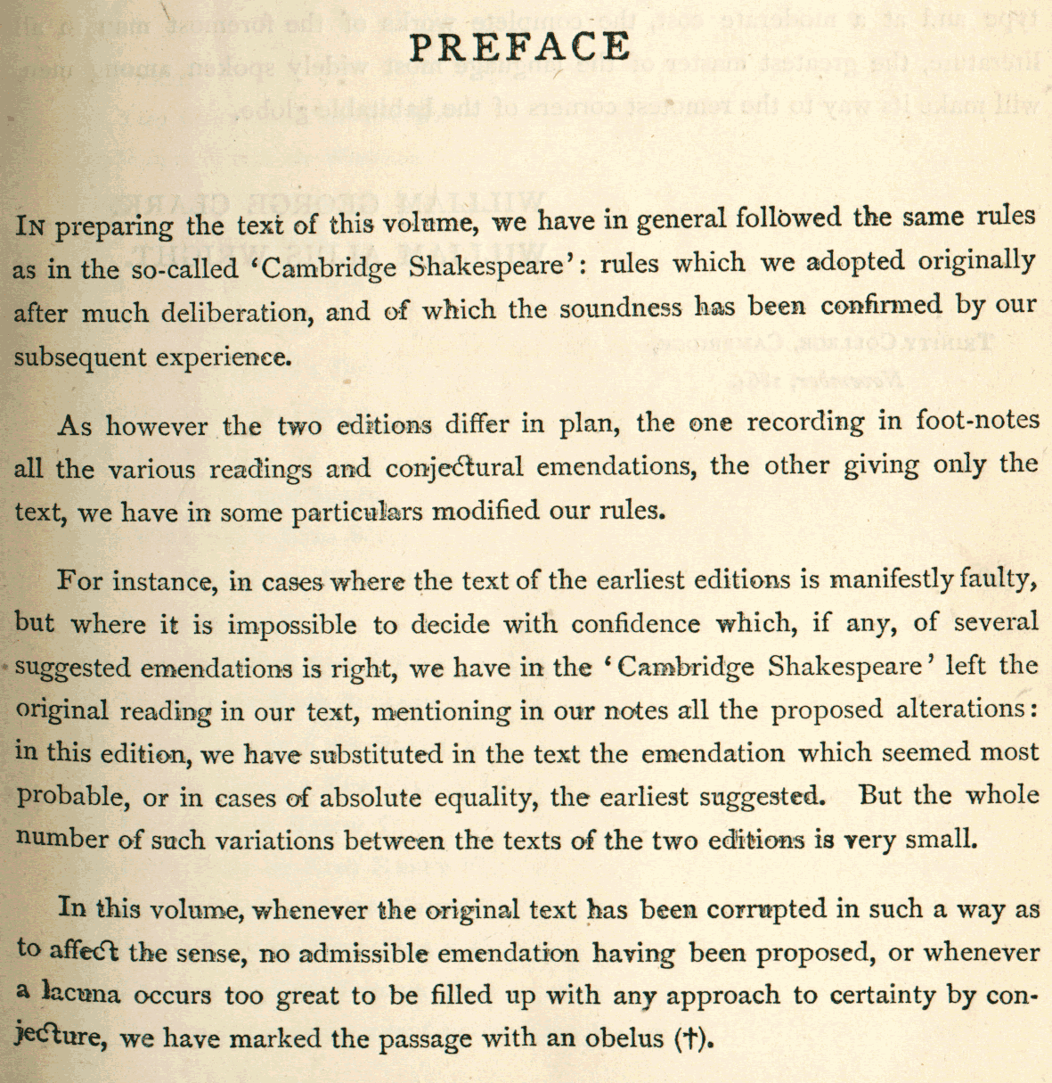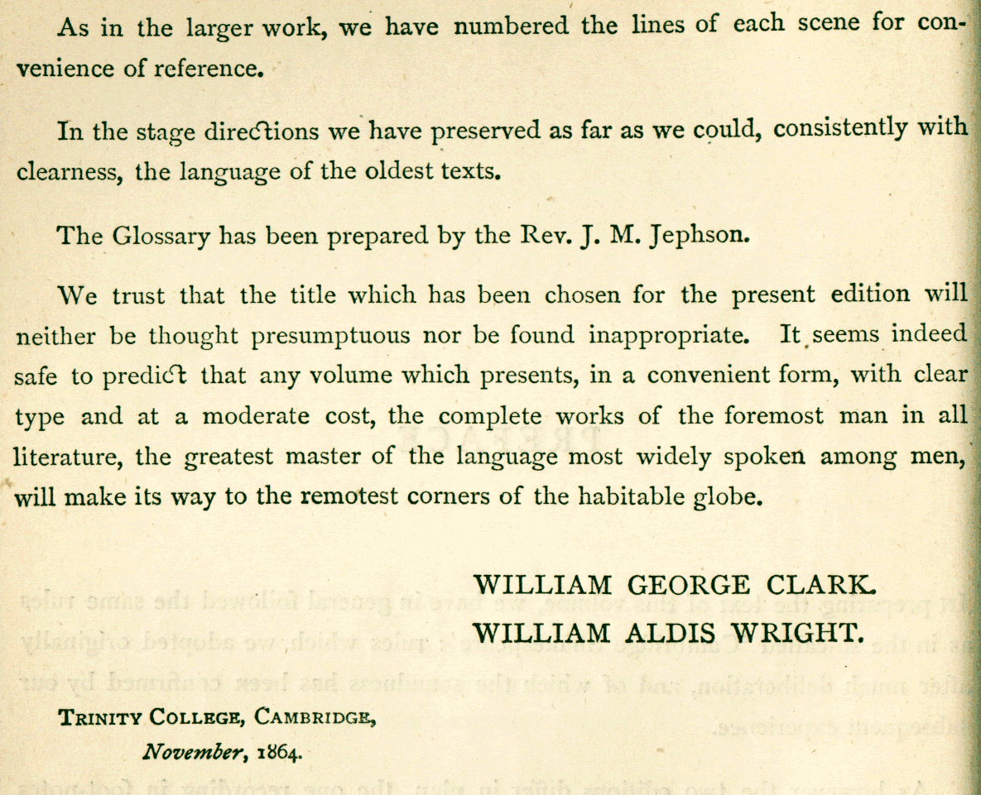

Figure 1. Preface to the 1864 Globe Edition

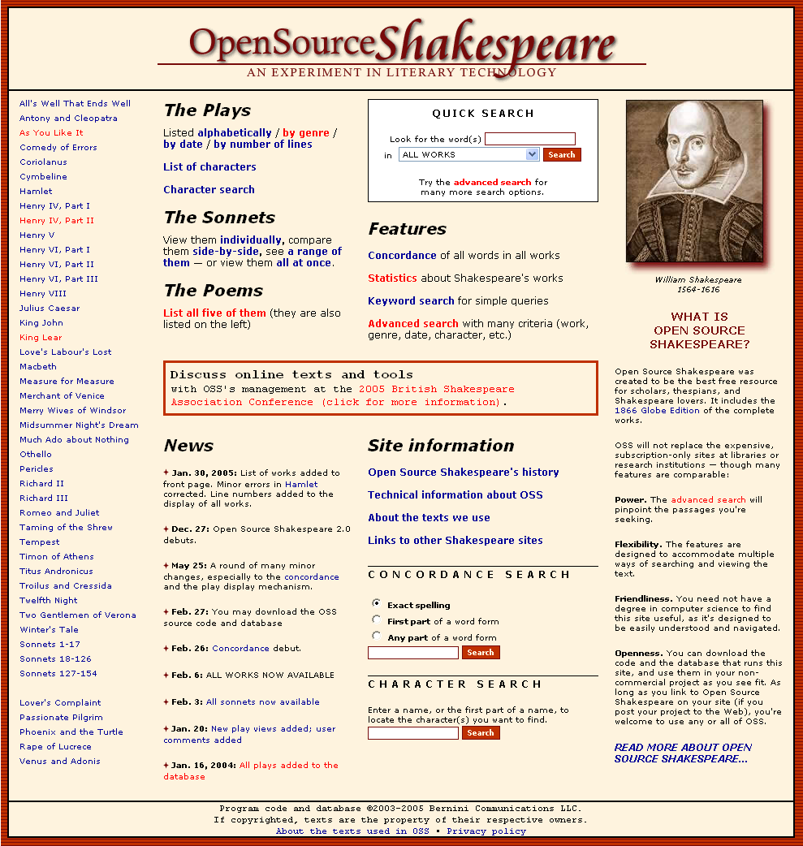

Figure 2. Open Source Shakespeare’s home page

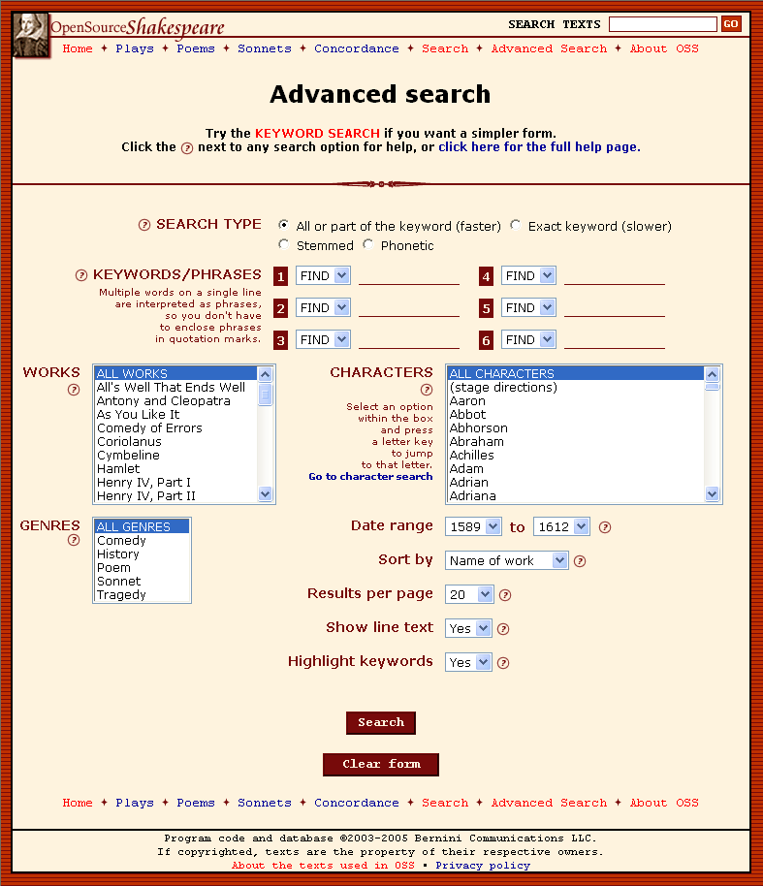

Figure 3. Advanced search

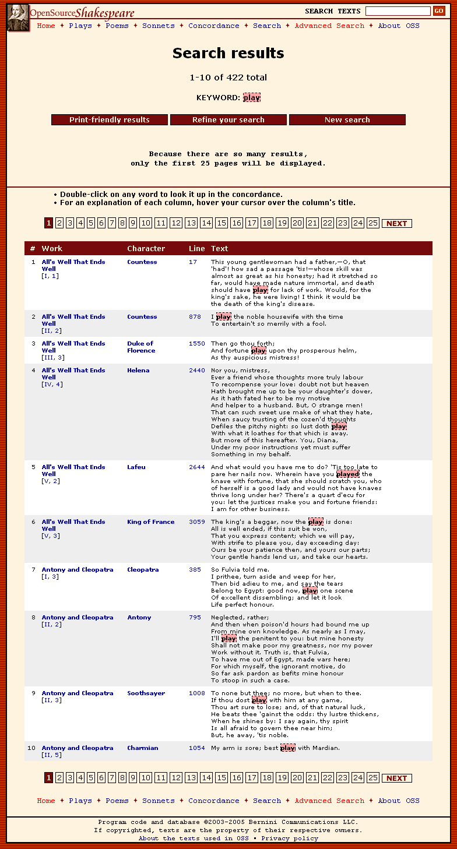

Figure 4. Search results

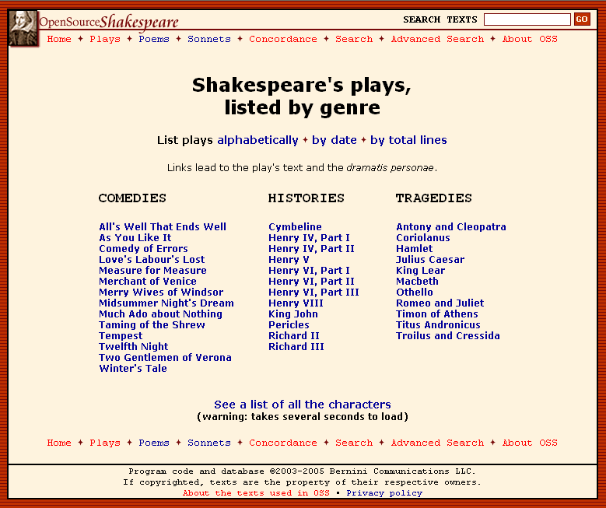

Figure 5. Play list

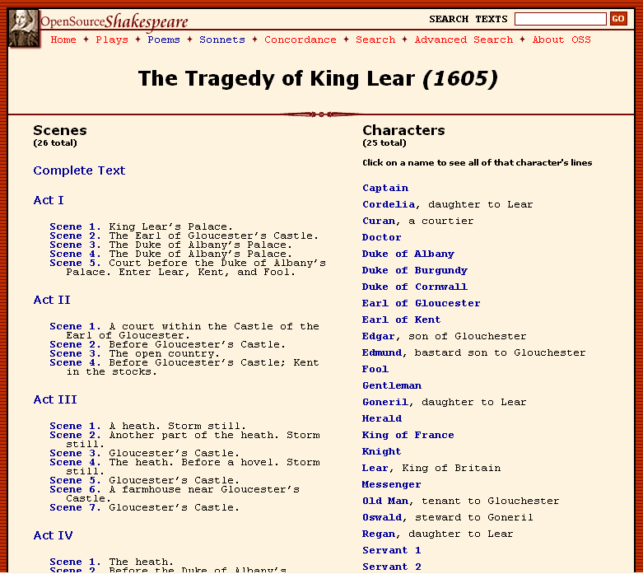

Figure 6. Play menu

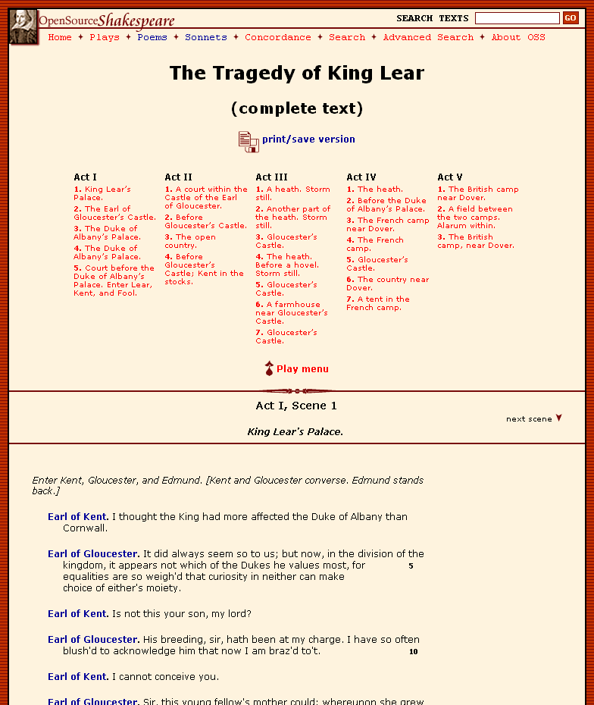

Figure 7. Play view

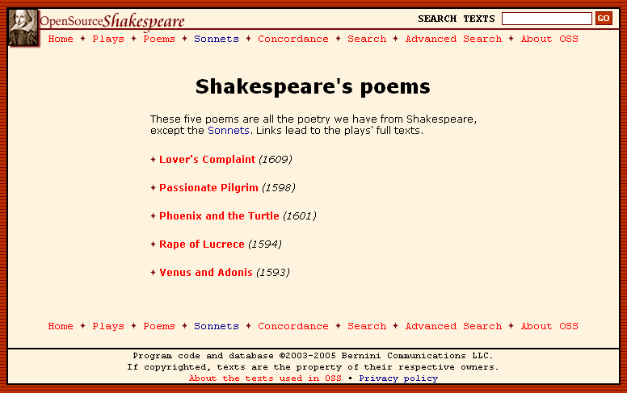

Figure 8. Poem list

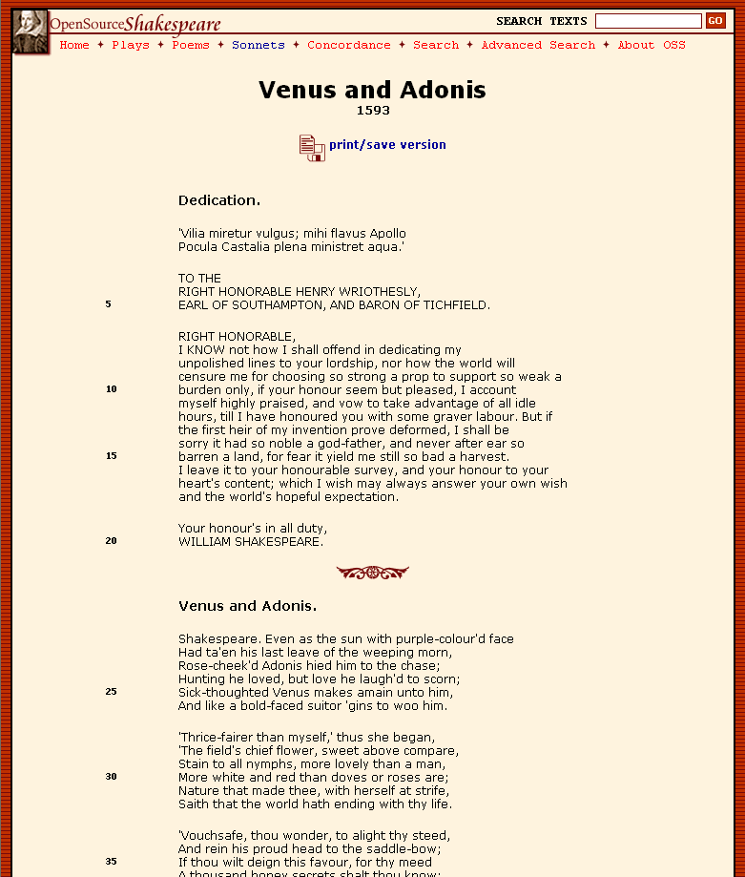

Figure 9. Poem view

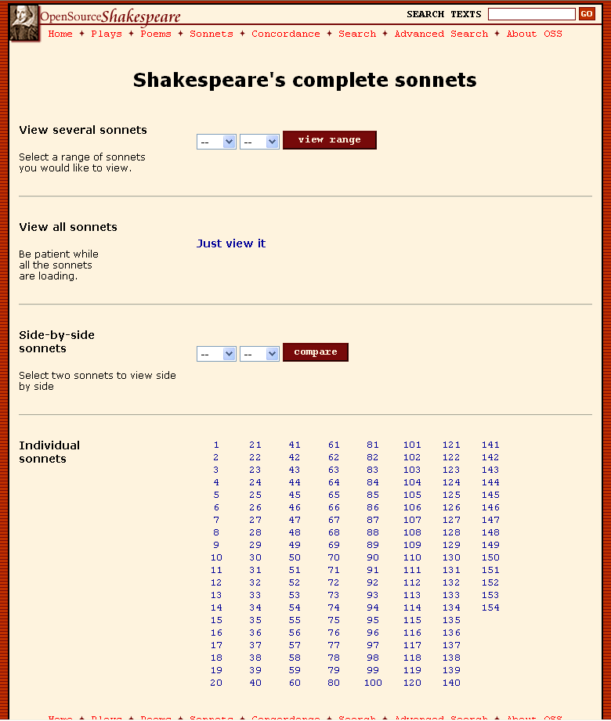

Figure 10. Sonnet menu

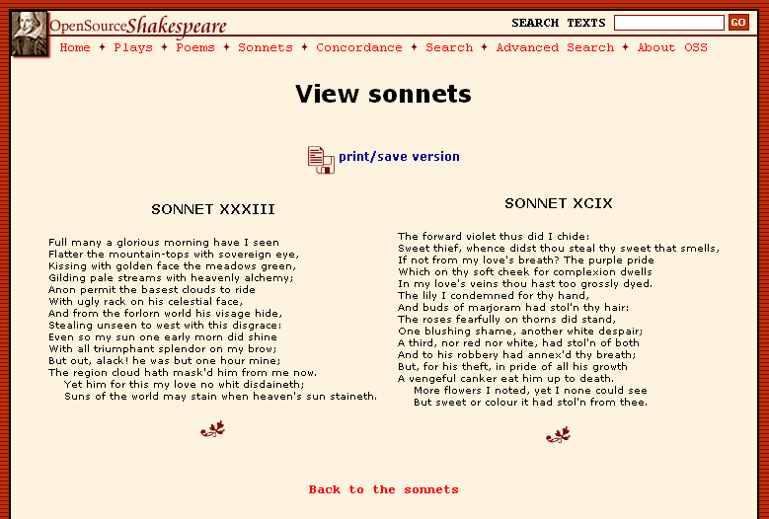

Figure 11. Sonnet comparison

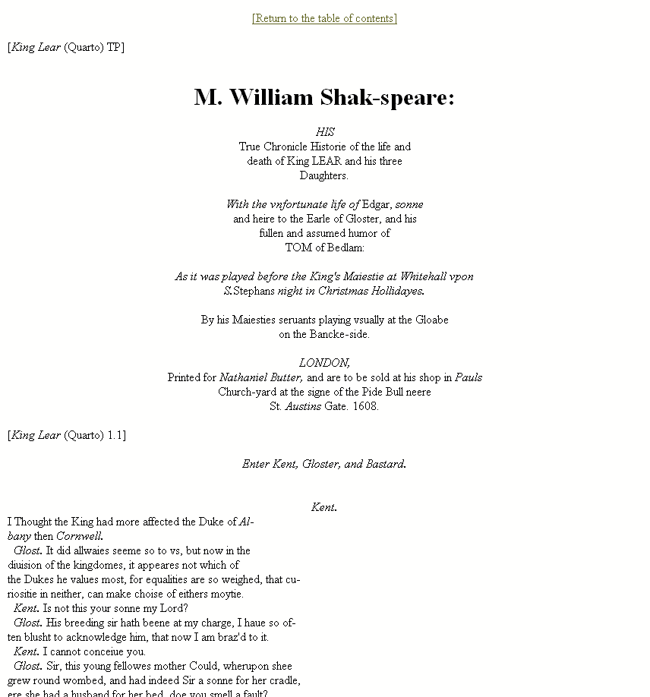

Figure 12. Original-spelling edition of King Lear, Act I, Scene 1

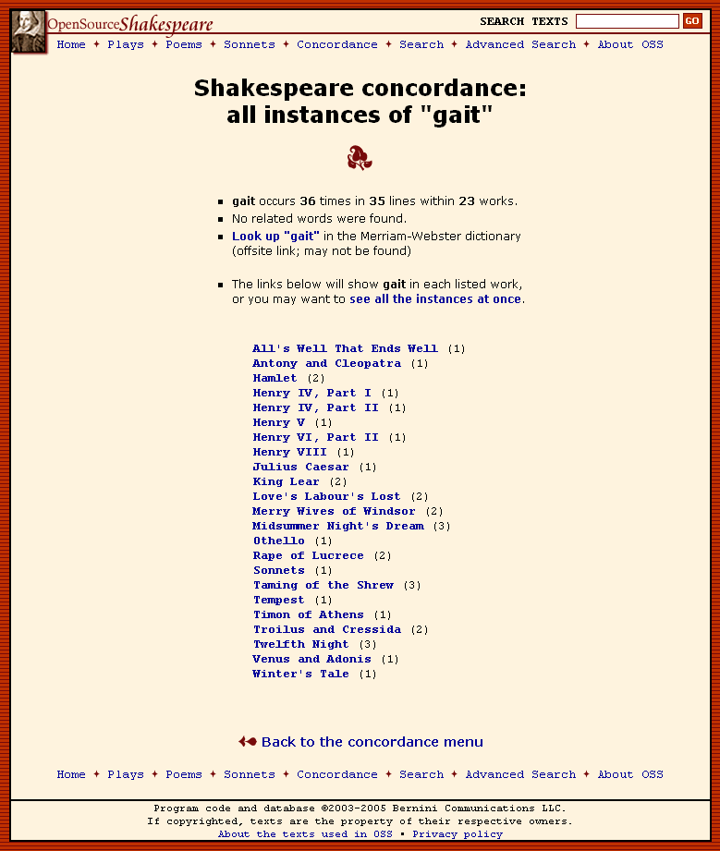

Figure 13. Concordance

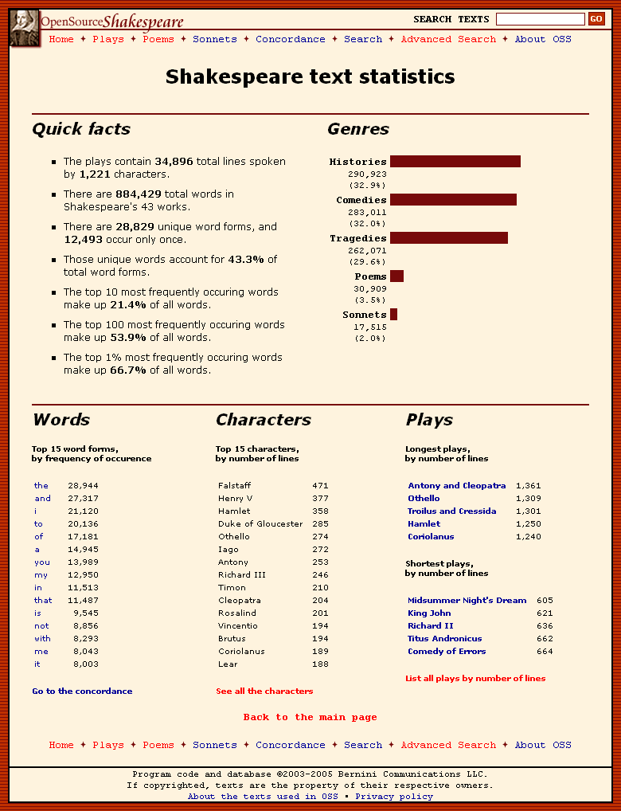

Figure 14. Statistics compiled by OSS

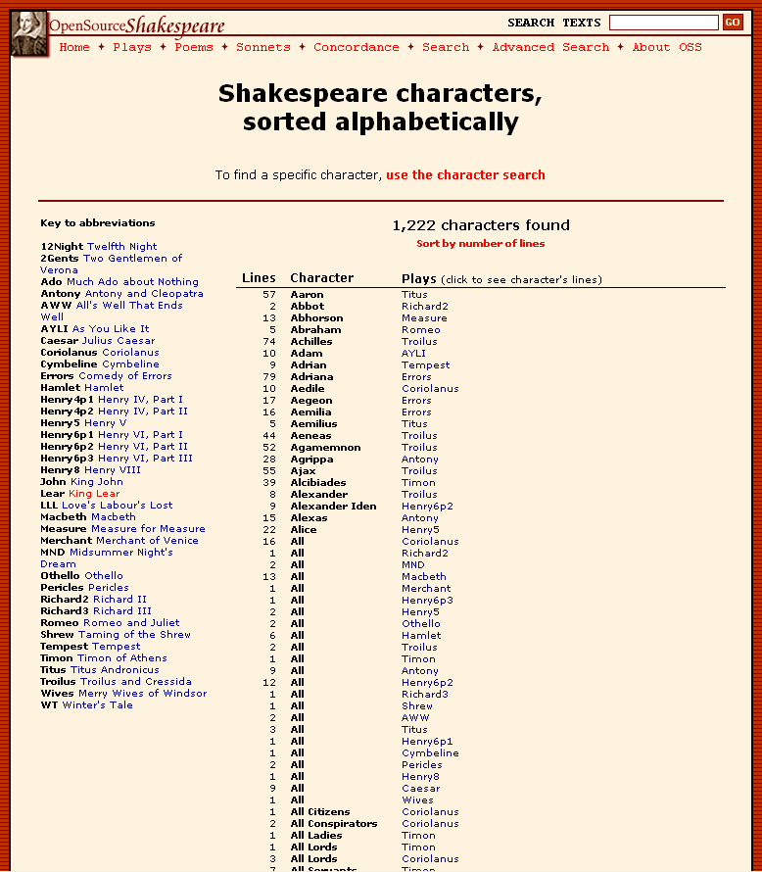

Figure 15. Character list

The Editing and Structure of Open Source Shakespeare

Moby Shakespeare’s texts collectively can be called a diplomatic edition of a critical edition: They are an edition produced by faithfully reproducing another edition, which was formed by conflating the folios and quartos. However, the texts could not be used “as is” if they were going to be fed into a database on their way to becoming Open Source Shakespeare.
The first challenge was to get the texts into a uniform order. The human eye can easily ignore small differences in formatting; a computer is far less forgiving. Sometimes the ends of lines were terminated with a paragraph break, sometimes two. Act and scene changes were indicated differently in different texts, and so on.
There was also the question of what to do with material that lies outside the characters’ spoken lines. I removed the dramatis personae at the beginning of each play and entered the character descriptions into a separate database table, so they can be seen in the play’s home page, but remain distinct from the text.
In editing the texts themselves, I made some minor changes for the sake of consistency. For instance, the Moby texts indent certain stage directions if they fall at the end of a line, and sometimes, a stage direction is indented by many spaces. This seems arbitrary, and although it may be following a convention in the printed texts, it adds nothing to either comprehension or aesthetics. For the most part, those spaces have been removed.
In the course of preparing the texts for the parser (about which more in a moment), many miscellaneous formatting errors came to light. Some of them were found by visitors after the site’s release. They also caught less visually obvious flaws, such as the assignment of a particular line to the wrong character (an error that was sometimes my fault, but usually the fault of the original Moby text.) There are, in all likelihood, many other errors remaining in the 28,000 lines, which will be corrected as users report them. Because there are over 860,000 words in the texts, I judged that my time would be more profitably spent on the site’s tools, and so the errors are fixed as they are reported.
When I prepared the texts, I made them readable by humans, but in a consistent format meant to be read by a machine. Specifically, they were intended for a parser, a program that reads a text and does something useful with it. In this case, the parser splits the texts into individual lines, determines their attributes, and feeds them into a database. (See Appendix B for a sample of the texts’ final format.)
I developed the parser at the same time I was feeding it the texts. Initially, I started with one play (King Lear) and wrote the first-generation version of the parser. As I formatted the texts, I improved the parser’s performance and power. For example, at first the parser did nothing other that read each line and figure out which character it belonged to, adding act and scene information as well. It was easy enough to determine how many words and characters were in each line, so I programmed the parser to capture that information and store those values in the database.
There are four search options in OSS: partial-word, exact-word, stemmed, and phonetic. Every online text search function will search for all or part of a word. That is, when a user searches for the word play, the function will find play, but also playing and replay. Finding an exact match, which would exclude playing and replay, is not ubiquitous in online text searches, but it is common and useful, so OSS can do it. There were two additional inexact, or “fuzzy,” search methods that intrigued me, stemmed searches and phonetic (sound-alike) searches, which are rarely used. I started experimenting with these searches to see if I could incorporate them.

The Porter stemming algorithm is a venerable method of determining the stems of words using standard grammatical procedures. It removes inflections from words, so playing, played, and plays are converted to the synthetic stem plai. But it has no idea that is and was are conjugated forms of be (though it will identify being as derived from the same stem.)
Another standard linguistic programming method is the Metaphone algorithm. This method forms a sound value from a word by stripping the vowels out of it, and then converts similar-sounding consonants into a common consonant. Porter and Metaphone are widely documented on the Internet, and you can find ready-made code for them written in many programming languages. That is important, because in OSS, the texts are sent through a parser written in one language (Perl), extracted through another language (SQL), and displayed through a third (PHP).
Once I gathered the code necessary to build stemming and phonetic searches, some choices presented themselves. In order to find a phonetic value, for example, you have to perform the following steps:
- Convert the user-supplied keywords into phonetic values
- Build a database query based on those values; and
- Execute the query in a reasonable amount of time.
I could think of two ways to perform step 3. First, the query could retrieve all of the lines in the scope that the user specifies – which could include all the works, and all 28,000 lines – and march through the results one-by-one, converting every word into phonetic values and comparing them with the user’s requested words. This is horrendously inefficient: Every stemmed or phonetic query would consume about 8-10 megabytes of memory, making it impossible to run more than a few queries simultaneously from different users. The execution time could balloon to as much as 5 minutes.

The second option was to calculate separate stemmed and phonetic lines for each natural language line, and store all three lines in the same database record. This makes the execution time identical to the exact-word search, i.e., less than 10 seconds. Figure 16 below illustrates how this looks inside the database. Note the words played and government, which are correctly stemmed to plai and govern, respectively; however, the words his and prologue are incorrectly assumed to be the inflected forms of the nonexistent stems hi and prologu.
WorkID | midsummer
ParagraphID | 881442
ParagraphNum | 1965
CharID | Hippolyta
PlainText | Indeed he hath played on his prologue like a child  [p]on a recorder; a sound, but not in government.
PhoneticText | INTT H H0 PLYT ON HS PRLK LK A XLT ON A RKRTR A SNT BT NT IN KFRNMNT
StemText | inde he hath plai on hi prologu like a child on a record a sound but not in govern
ParagraphType | b
Section | 5
Chapter | 1
CharCount | 101
WordCount | 19

Figure 16. A character’s line in the database

Of the two fuzzy search options, the stemming algorithm appears to be more useful. Metaphone identifies their, there, and they’re as homophones, but for finding certain words, it is useless. To cite one egregious example, searching for guild returns called, could, cold, glad, killed, and quality. Porter stemming has its limitations, particularly with irregular verbs, but it will generally perform as expected. The best way to link an inflected word with its root would be through a brute-force approach: Take at least 100,000 English words, annotated with pronunciations, stems, and any other value worth attaching, and put them in a database table. Then, when the parser is processing the texts, it can look up each word and it will not have to make an educated guess for the stem and the pronunciation – the parser can find that information in the table. Doing that would be simple, but the problem is obtaining the word list, and verifying its quality. Ian Lancashire suggested this approach in 1992:
…with some information not commonly found in traditional paper editions, software can transform texts automatically into normalized or lemmatized forms. One such kind of apparatus suitable for an electronic edition is an alphabetical table of word-forms in a text, listed with possible parts-of-speech and inflectional or morphological information, normalized forms, and dictionary lemmas. With such an additional file, software might then ‘tag’ the text with these features and then transform it automatically into a normalized text or a text where grammatical roles replace the words they describe. Such transformations have useful roles to play in authorship studies and stylistic analysis (Lancashire, “Public-Domain”).
After ten or twelve plays, the text formatting was more or less standardized and complete, and it was just a question of re-formatting the remaining works. Act and scene changes had their own separate lines, so the parser would know where they were. At first, stage directions were a separate category of lines. I found that this was unnecessary, as they could be assigned to a “character” with the identifier of xxx in the database.

Two issues, one minor and one fairly significant, remain with the texts and the database that stores them. There are a small but not inconsiderable number of lines that are attributed to more than one character. Some are marked “Both,” and the speakers are easy to identify from the context. But what to do about lines marked “All”? Should they be attributed to every single character on the stage? Presumably – but how do you determine who is on stage, given the paucity of stage directions in the original texts? That requires editorial discernment that I do not have. Further, since one of my goals was to finish this project before my natural death, I did not want to painstakingly go through hundreds of lines with multiple speakers and figure out who was saying what. Also, this would require increasing the complexity of the database, because each line is assigned to one speaker, and one speaker only (indicated by the field “CharID” in Figure 16). Changing that would mean re-engineering several database tables, as well as all of the pages which use those tables’ data. In the end, every time a line was marked as “Both” or “All,” I created a new character in that play called “Both” or “All.” Not the most satisfactory arrangement, but good enough.
The other issue is fairly significant and noticeable. Between Acts IV and V of Henry IV, Part 2, King Henry IV dies. Until that point, the Moby text refers to “Prince Hal,” and then after his coronation, he is “King Henry V.” Making a computer understand that transition is tricky, for reasons similar to the multi-character lines described above. There is only one name for each character, just as there is only one character for each line. You could have two different characters for Henry, one for Prince Hal and one for the king. If a user wanted to search all of Henry’s lines for the word happy, he would have to know that the same person’s lines were split into two different characters, and perform the search accordingly. That seems too much to expect of the casual user.

So there is still one name for each character, which makes for several goofy-looking passages of dialogue. Take a look at this passage in Henry V, Act 4, Scene 5:
Henry IV. But wherefore did he take away the crown?
[Re-enter PRINCE HENRY]
Lo where he comes. Come hither to me, Harry.
Depart the chamber, leave us here alone.
Exeunt all but the KING and the PRINCE
Henry V. I never thought to hear you speak again.
The choice came down to three possibilities: 1) keeping the character names consistent, no matter whether their name or rank changed, which might cause a small amount of confusion for some readers; 2) crippling the utility of the search function and frustrating users; or 3) re-engineering major portions of the database and re-writing the pages which use them. As with multi-character lines, the amount of time and effort necessary to do proper name changes was not proportional to the results, and I took option number one.
Once the text formatting and parser functions were in a workable status, it was just a question of repeating the same procedure for each play. This is the final procedure for adding a work:
- Manually enter the character information into the database, including character descriptions. Also, the database indicates character abbreviations, so the parser will know that Ham. corresponds to the character of Hamlet.

- Remove all extraneous information at the beginning of the play (frontispiece, character information, notes, etc.)
- Perform several search-and-replace operations to properly mark the stage directions, act and scene indicators, and character lines.
- Eyeball the text, searching for obvious errors.
- Run the parser on the text. Each time the parser comes across an error, it halts the program and reports the line number where it choked. The line is then amended.
- Repeat step 5 until there are no more errors.
- Display the play on the testbed Web site, again looking for errors that a computer might not catch but a human would see.
This procedure might seem very complex, and indeed it took many hours to perfect. However, the last fifteen or sixteen plays went very quickly, as it was just a question of repeating the same process over and over. I got to the point where I could finish one or two plays an hour, depending on how many discrepancies there were in the texts.
Next, I moved on to the poems and sonnets. Since I had been working on plays thus far, my database’s schema reflected the structure of a play: Each had an entry in the Plays table, and each play had Acts, Scenes, and Lines. I could have kept using this format behind the scenes, as this schema is largely hidden from the user. But I “universalized” the database schema instead. Plays became Works, Acts became Sections, Scenes became Chapters, and Lines became Paragraphs. Any literary work could be broken into smaller elements by a parser and stored in this schema, if it were used in another project.

The poems are heterogeneous in format, but they were easy to convert, as their structure was fairly simple compared to a play (no stage directions, and all of the lines were assigned to a “character” called “Shakespeare.”) I decided to treat the sonnets as a single work with one section and 154 chapters.

The final texts of Open Source Shakespeare do differ somewhat from the Moby edition, though the differences are not substantive. OSS adds a through line-numbering (TLN) system, which means that within each play, the line numbering starts at the beginning and continues through to the end, without restarting the numbering at act and scene divisions. The Norton edition uses TLN, as do other electronic editions such as the Internet Shakespeare Editions; the Variorum Handbook mandates TLN (Variorum 22). The advantage of TLN is that from the line number, you get a rough idea of where the line falls in the play. Scene-by-scene numbering shows where a line falls within a particular scene. In my opinion, TLN is the better system overall, because the length of the plays differs much less than that of individual scenes, and thus what it conveys is more useful. The Variorum Handbook and others number the titles of the play as “0,” or “0.1, 0.2” etc. for multi-line titles. In OSS, the play titles are considered attributes of the play, not a part of it. Act and scene indicators are also removed from the text itself, although the scene’s setting (e.g., “Another part of the forest”) is captured and stored as an attribute of the scene.

Displaying the Texts

When I first integrated the texts, the parser, and the database, I created a Web site to display the few plays of Open Source Shakespeare. There were two Web pages for each play: The first was the menu page that showed the play’s acts and scenes on the left, and a character list on the right (Figure 5). This page linked to the text display page, which shows the text of a range of scenes (Figure 6). The range might include anything from a single scene to the entire play. These pages are still in use, although they have many refinements.
At first, the text display page just showed the act and scene indicators, with the characters’ lines and stage directions underneath. The only navigational aid was a link back to the play menu. Users could not jump from one scene to the next, nor from one act to the next. I thought that creating fancier navigation aids, which would require at least one or two additional database queries, would slow down the page display and frustrate users. Once I tested those features, it only slowed down the page by a fraction of a second, so I gladly included them.
Looking at an open-source encyclopedia, I noticed a small yet nifty feature. When a user double-clicks on any word, the site redirects the user to a page with a definition of that word. I appropriated this feature for OSS, and so when you click on a word while viewing a work, or you click on a word in the search results, it pulls up that word in the concordance.
The last significant thing added to the play view function was the line number display. This was actually less straightforward than it sounds. Displaying every line number to the right of the line would have been easy to program, but they would look ugly. The convention of displaying line numbers every five lines, followed by Harrison and others, looked quite readable on the screen. (The print version of the Globe shows them every ten lines, but the typeface is very small – perhaps 6.5 points, about half the height of the text on this page – and the lines are much closer together.)
The problem was that the text lines are not stored one-by-one in the database, they are stored as part of a character’s line, so a soliloquy spanning forty lines of text is stored as a long, single string of data, with the indicator [p] showing where each line break occurs within that line. That soliloquy might begin on line 937 within the play, so the first line would not be numbered because it is not divisible by five. The numbering would need to begin with the fourth line break (line 940) and continue every five lines until 955.
The play view function does this by looping through each break within the line. If the break’s number is a multiple of five, then the line number is displayed at the right of the line, separated by an adequate amount of whitespace. I feared that performing these calculations might slow down the play view process, which it did, but only by less than a second, a trivial expenditure of time to gain this valuable feature.
Although they were stored in the same table as the plays, the poems and sonnets must be displayed differently because they look different. The poems were rather easy, although their forms vary significantly. poem_view.php, the page that displays the poems, has to take into account which poem it is displaying, as some plays have more than one part . (Figure 8 shows the poem list, and Figure 9 shows the poem view.)
To display one sonnet is a simple thing, but not as useful as being able to display more than one (Figure 10). I settled on four different ways of viewing sonnets:

- A single sonnet
- Two sonnets side-by-side
- A range of sonnets selected by the user; and
- All sonnets at once.
This arrangement lets readers and scholars compare sonnets as their needs require. The only difficulty I ran into was sonnet 99, which has fifteen lines instead of the usual fourteen. The parser, when it was reading the sonnets, looped through all of them sequentially, expecting to see the same number of lines in each one. I spent about a half-hour in frustration, looking through the code and wondering why the parser was misreading sonnets 100 through 154, thinking it was a flaw in the program itself. Once I saw the error’s cause, I added a few lines of code to handle the exception, and all was well (Figure 11).
There was a popular Shakespeare concordance at www.concordance.com, but unfortunately the owner died years ago, and his site disappeared shortly thereafter. The Works of the Bard can pull up all the instances of a word and display their contexts (Farrow), but no other site I found could do even that – the other sites had search mechanisms which returned a list of scenes that you could view if you clicked on them, but they did not provide the word’s context. I wanted to go beyond a listing of instances, and set up a “real” concordance where people could browse and look up words, like a printed concordance.
To do this, I added a function to the parser so it would keep a count of each individual word form as lines were added to the database. I use the term “word form” to mean an inflected instance of a particular word. (Lexicologists would use the term “lemma,” but OSS is supposed to include a non-academic audience, and I thought using that term might turn off potential users.) Thus play is the word, and plays and playing are the word forms. I use “word instance” to describe a word form at a particular place in a particular work.

Now, you can tell at a glance how many instances there are of a particular word form, and OSS does not have to do any extra calculations – the parser has already performed all of those counts. Once you find a word form you wish to see, either in a list or through the specialized word search function, you can click to see a breakdown of how many times it appears in each works (Figure 13). You can then display the lines containing the word form.
The word form information also undergirds much of the data for the Statistics page (Figure 14). The top 15 word forms are listed, as well as some individual facts that shed some light on Shakespeare’s use of language. For instance, there are 12,493 word forms that are used only once in all of his works. Also, the top 100 word forms make up 53.9% of all the word instances.
One final, modest feature is the character search (Figure 15). As there are over 1,200 characters in Shakespeare’s plays, and some of them have similar or identical names, it is useful to have help when sifting through them: There are two Portias, three Demetriuses, five Antonios, twenty-one characters listed as “Servant,” many lines listed as “All,” etc. If you know the name, you can search for it, or the first part of the name if you are not sure of the spelling.

Conclusion: The Future of Open Source Shakespeare

Open Source Shakespeare has fulfilled its initial goals and in several respects gone beyond them. All but the most complex searches are completed in ten seconds or less, meaning it is quick. “Quick” is admittedly a relative term, and reflects my personal judgment that most users will be content to wait a few moments for accurate results. But simple keyword searches are typically returned in two seconds or less, and often take a mere fraction of a second. Right now, OSS is hosted on a shared Web server, but if it had a dedicated server, it would be blazingly fast. The big functions – advanced search, concordance, and statistics page – are all there, with the capabilities listed at the beginning of this paper. Of course, the site includes Shakespeare’s complete works, too.
Where will OSS go from here? Dozens of people have downloaded the OSS source code and database. A few people have inquired about its use in their own literary projects. Although OSS is designed with freely available tools and can be easily replicated elsewhere, modifying it to do something else would take a decent amount of work. This is not because it would be difficult, from a programming perspective – there are no arcane programming techniques, and any intermediate-level programmer could modify the code if he wished. The problem is the time commitment. A person would have to learn how to mark up the texts, modify the parser to accommodate them, set up some data in the database, and modify the view pages to display the new texts. Again, none of that is difficult, but it would take a while to execute.
On the other hand, that effort would pay off handsomely. The developer who modifies OSS would not have to design a database or think through all of the ramifications of storing a collection of texts and displaying them. The collection would have a ready-made concordance, a search function, and the statistics page could be adjusted for the new texts, too. OSS could process non-English texts, even with non-Western character sets, as all of the technologies used to build the site can handle UTF-8 characters, which display any language included in that standard.
What about the future of OSS itself? It is not in its terminal form – I hope to continue extending and refining it long after this paper is completed. I see three main possibilities for improvement:
1. Include multiple versions of the texts. The Internet Shakespeare Editions has already transcribed the folio and quarto versions of each text, with the original spelling. Having an editorial edition (Moby) alongside the early texts would be ideal: readers could use Moby for everyday use, and scholars could compare the early texts onscreen. There are some technical challenges to be overcome – namely, how does one collate, or “map,” the passages in one text to the passages in another? What about passages that are in one text, but not in another text – how will they be stored or displayed? I have no doubt that these issues are soluble, but they require careful thought.
2. Include folio and quarto images, audio clips, and video clips. There are sites such as the Electronic Text Library that will let you look up a passage, then display an image of a First Folio page onscreen, where you can see the passage yourself (Electronic). This strikes me as an extremely useful tool for scholars. Keeping track of which passage is on what page is a monumental task, so OSS would have to use texts that were already mapped to the pages. Such texts exist; whether or not they can be used legally is a different matter.

Considering the inclusion of audio and video clips may be a flight of fancy. It would involve taking very large computer files and breaking them up into smaller files, then mapping them to each passage. Yet would it not be wonderful to read a soliloquy, and then hear it read out loud – or, when you are trying to understand a passage of dialogue, to see actors interpret it on your computer screen?
I do not underestimate the amount of work involved with this. Completing all of the works would take years of full-time effort. But in the short term, I would like to take a single scene – most likely Act I, Scene 1 of “Romeo and Juliet” – and add multiple text versions, folio and quarto facsimiles, audio clips, and video clips. I have that particular scene in mind because the folio and first quarto versions differ significantly, so it would show the value in comparing variant texts side-by-side. Also, the scene has a lot of action, and it is universally well-known, even to high school students who started to read the play and then decided to fake it for the test.
3. Build another site, with another text collection. I have thought of the Gospels or Chaucer’s works as possible candidates for a new collection, to demonstrate that OSS’s parser, database, and display code could potentially ingest and display any kind of literary work. That may happen eventually, but the thought of embarking on another project like Open Source Shakespeare, even one requiring far less effort, makes me want to lie down for a while.
If I had thought about it, I would have recorded the amount of time I spent developing OSS from its inception. Since I started it on a whim in the Kuwaiti desert, I have spent at least 500 hours on it, and probably significantly more. Using a relatively low billing rate of $100 an hour, that would make OSS’s theoretical value something like $50,000.

That does not mean it could be sold for that much. If it were used commercially, it would have to use a modern editorial edition as its texts, which would have to be licensed from its publisher. Then the texts would have to be converted to the OSS format. Still, with a month of steady, full-time work, it could be done.
Ultimately, I would consider donating OSS to a foundation or an educational institution. I could make some changes so the whole thing could work on a single server, or a group of servers, and after that it would pretty much run itself. I would only do this if the recipient wanted to continue the project as a going concern; I would not want to give it away, only to watch it die from neglect as other sites arise to surpass it.
It is also satisfying to know that OSS is gaining public attention. I have received unsolicited positive messages from every part of the world, including professors from the U.S., Canada, the U.K., and Argentina. Dozens of other Web sites have linked to it, many of them singling it out for praise. About twenty sites have it listed on their “permanent” links, with blogs making up most of the total, but some institutional sites link to it as well, including the Cleveland Public Library and the Shakespeare Theatre of Washington, D.C.
According to Awstats, a program that generates site usage reports, OSS had about 7,000 unique visitors in April 2005, a respectable total for its seventeenth month of release. To give an idea of the site’s global appeal, users in each of the following non-English-speaking countries downloaded more than a hundred pages from the site: Germany, Japan, the Netherlands, Hungary, Hong Kong, China, and Singapore.
If nothing else, I hope Open Source Shakespeare demonstrates that you can build a useful literary site using off-the-shelf technologies, public-domain texts, and Web development skills. There are many other Web-based projects that use the same elements, but I believe my site is unique in that it is free, and that you can download it for non-commercial use. I hope that other people will use the code and database as examples for their own work, and I hope that Shakespeare lovers and scholars everywhere continue to embrace it.

Bibliography

Bibiliography
Allen, Michael J.B., ed. Shakespeare’s Plays in Quarto. By William Shakespeare. Various dates. Berkeley: University of California Press, 1981.
Anonymous. “possible error?” E-mail to Eric M. Johnson. 3 March 2005.
Bartlett, John. A Complete Concordance or Verbal Index to Words, Phrases, and Passages in the Dramatic Works of Shakespeare. New York, St. Martin's Press, 1962.
Berry, Craig, Martin Mueller, et al., eds. “The Nameless Shakespeare.” Web site. 2003. 15 March 2005. <URL: http://www.library.northwestern.edu/shakespeare/lcc/ShakespeareSplash.html>.
Best, Michael, ed. “Internet Shakespeare Editions.” Web site. 10 January 2003. 15 March 2005 <URL: http://ise.uvic.ca/Foyer/index2.html>.
Best, Michael. “Afterword: Dressing Old Words New.” Early Modern Literary Studies 3.3 / Special Issue 2 (January, 1998): 7.1-27 <URL: http://purl.oclc.org/emls/03-3/bestshak.html>.
Blake, N.F. A Grammar of Shakespeare’s Language. Hampshire, UK: Palgrave Publishers Ltd, 2002.
Bowen, William R. “Iter: Where Does the Path Lead?” Early Modern Literary Studies 5.3 / Special Issue 4 (January, 2000): 2.1-26 <URL: http://purl.oclc.org/emls/05-3/bowiter.html>.
Bowers, Fredson. On editing Shakespeare and the Elizabethan Dramatists. University of Pennsylvania Library, 1955.
Bushnell, Rebecca. “Reinventing Rare Books: The 'Virtual Furness Shakespeare Library' at the University of Pennsylvania.” Early Modern Literary Studies 5.3 / Special Issue 4 (January, 2000): 5.1-19 <URL: http://purl.oclc.org/emls/05-3/bushfurn.html>.
Busse, Ulrich. Linguistic Variation in the Shakespeare Corpus: Morpho-syntactic Variability of Second Person Pronouns. Philadelphia: John Benjamins Publishing Co., 2002.
Craig, W.J., ed. The Oxford Shakespeare. London: Oxford University Press: 1914; Bartleby.com, May 2000. 15 March 2005 <URL: http://bartleby.com/70>.
Crain, Caleb. “The Bard’s Fingerprints. Lingua Franca 8:5 (July/Aug. 1998): 29-39.

Electronic Text Center, University of Virginia. “The Comedy of Errors.” 1998. 15 March 2005 <URL: http://etext.lib.virginia.edu/etcbin/toccer-new2?id=MobCome.sgm&images=images/modeng&data=/texts/english/modeng/parsed&tag=public&part=all>.
Farrow, Matty. “The Collected Works of Shakespeare [The Works of the Bard]” Web site. Unknown. 15 March 2005. <URL: http://www.it.usyd.edu.au/~matty/Shakespeare/test.html>.
Finn, Patrick. “@ the Table of the Great: Hospitable Editing and the Internet Shakespeare Editions Project.” Early Modern Literary Studies 9.3 / Special Issue 12 (January, 2004): 2.1-29<URL: http://purl.oclc.org/emls/09-3/finntabl.htm>.
Galey, Alan. “Dizzying the Arithmetic of Memory: Shakespearean Source Documents as Text, Image, and Code.” Early Modern Literary Studies 9.3 / Special Issue 12 (January, 2004): 4.1-28 <URL: http://purl.oclc.org/emls/09-3/galedizz.htm>.
Gómez-Nelson, Julia (National Endowment of the Arts). Personal Interview. 12 March 2004.
Greg, W.W. The Shakespeare First Folio: Its Bibilographical and Textual History. Oxford: Clarendon Press, 1955.
Greg, W.W., ed. Romeo and Juliet: Second Quarto, 1599. Shakespeare Quarto Facsimiles. 6. Oxford: Clarendon Press, 1949.
Grusin, Richard, and J. David Bolter. Remediation: Understanding New Media. Cambridge, Mass.: MIT Press, 1999.
Hinman, Charlton. The Printing and Proof-Reading of the First Folio of Shakespeare. 2 vols. Oxford: Clarendon Press, 1963.
Honigmann, E.A.J. The Stability of Shakespeare’s Texts. Lincoln, Neb.: University of Nebraska Press, 1965.
Hosley, Richard, Richard Knowles, and Ruth McGugan, eds. Shakespeare Variorum Handbook. New York: Modern Language Association of America, 1971.
Howard-Hill, T.H. Shakespearean Bibliography and Textual Criticism. Oxford: Clarendon Press, 1992.
Johnson, Eric M. “Shakespeare Text Statistics: Open Source Shakespeare.” Web site. 8 March 2005. 15 March 2005. <URL: http://www.opensourceshakespeare.org/stats>.

Jones, John. Shakespeare at Work. Oxford: Clarendon Press, 1995.
Kökeritz, Helge, ed. Mr. William Shakespeares Comedies, Histories, & Tragedies [First Folio]. By William Shakespeare. 1623. New Haven: Yale University Press, 1954.
Kuhn IV, James C. (Folger Shakespeare Library). Personal Interview. 4 November 2003.
Lancashire, Anne. “What Do the Users Really Want?” Early Modern Literary Studies: A Journal of Sixteenth- and Seventeenth-Century English Literature, 3:3 (Jan. 1998): 22.
Lancashire, Ian. “The Common Reader’s Shakespeare.” Early Modern Literary Studies 3.3 / Special Issue 2 (January, 1998): 4.1-12 <URL: http://purl.oclc.org/emls/03-3/lancshak.html>.
Lancashire, Ian. “The Public-Domain Shakespeare.” MLA Convention. Sheraton New York Hotel, New York. 29 Dec. 1992. <URL: http://www.library.utoronto.ca/utel/ret/mla1292.html>.
Levenson, Jill L. Romeo and Juliet. Oxford Shakespeare. Oxford: Oxford University Press, 2000.
Marcus, Leah S. Unediting the Renaissance: Shakespeare, Marlowe, Milton. London: Routledge, 1996.
Massai, Sonia. “Redefining the Role of the Editor for the Electronic Medium: A New Internet Shakespeare Edition of Edward III.” Early Modern Literary Studies 9.3 / Special Issue 12 (January, 2004): 5.1-10 <URL: http://purl.oclc.org/emls/09-3/massrede.htm>.
Murphy, Andrew. Shakespeare in Print. Cambridge, Cambridge University Press, 2003.
Neuhaus, H. Joachim. “Shakespeare Database Project.” Web site. 20 September 2000. 15 March 2005 <URL: http://www.shkspr.uni-muenster.de>.
Officer, Lawrence H. “Comparing the Purchasing Power of Money in Great Britain from 1264 to 2002.” Economic History Services, 2004. 15 March 2005 <URL : http://www.eh.net/hmit/ppowerbp>.
Orgel, Stephen and Sean Keilen, eds. Shakespeare and the Editorial Tradition. New York: Garland Publishing, 1999.
Orgel, Stephen. The Authentic Shakespeare, and Other Problems of the Early Modern Stage. New York: Routledge, 2002.

Schmidt, Alexander. Shakespeare Lexicon. 2nd ed. Berlin: G. Reimer, 1886.
Seary, Peter. Lewis Theobald and the Editing of Shakespeare. Oxford: Clarendon Press, 1990.
Shakespeare, William. Shakespeare: The Complete Works. Ed. G.B. Harrison. New York: Harcourt, Brace and Company, 1952.
Shakespeare, William. The Tragedy of Macbeth. Ed. Ebenezer Charlton Black and Andrew Jackson George. New Hudson Shakespeare. Boston: Ginn and Co., 1908.
Shakespeare, William. The Unabridged William Shakespeare [Globe Edition]. Ed. William George Clark and William Aldis Wright, 2nd ed. 1911. Philadelphia: Courage Books, 1997.
Shakespeare, William. The Works of Shakespeare [Globe Edition]. Ed. William George Clark and William Aldis Wright. 1864. Philadelphia: J.B. Lippencott and Co., 1867.
Siemens, R.G. “Disparate Structures, Electronic and Otherwise: Conceptions of Textual Organisation in the Electronic Medium, with Reference to Electronic Editions of Shakespeare and the Internet.” Early Modern Literary Studies 3.3 / Special Issue 2 (January, 1998): 6.1-29 <URL: http://purl.oclc.org/emls/03-3/siemshak.html>.
Spevack, Marvin., ed. The Harvard Concordance to Shakespeare. Cambridge, Mass., Belknap Press of Harvard University Press, 1973.
Stevenson, Burton. The Standard Book of Shakespeare Quotations. New York: Funk & Wagnalls Company, Inc., 1953.
Taylor, Gary. Reinventing Shakespeare. New York: Weidenfeld & Nicholson, 1989.
Thompson, Ann. Which Shakespeare? A User’s Guide to Editions. Philadelphia: Open University Press, 1992.

Van Doren, Mark. Introduction. A Midsummer Night’s Dream, As You Like It, Twelfth Night, The Tempest: Four Great Comedies. Cambridge Text and Glossaries Complete and Unabridged. By William Shakespeare. Ed. William Aldis Wright. New York: Pocket Books, 1955.
Ward, Grady. “Grady Ward’s Moby.” Web site. October 2000. 27 July 2005. <URL: http://www.dcs.shef.ac.uk/research/ilash/Moby>.
Werstine, Paul. “Hypertext and Editorial Myth.” Early Modern Literary Studies 3.3 / Special Issue 2 (January, 1998): 2.1-19 <URL: http://purl.oclc.org/emls/03-3/wersshak.html>.

Ziegler, Georgianna (Folger Shakespeare Library). Personal Interview. 4 November 2003.

APPENDIX A: Database structure and documentation
Database tables, with descriptions of each field in the tables.
Works

WorkID | Unique identifier for the work
Title | Common title for the work (e.g., “Hamlet”)
LongTitle | Full title (e.g., “Tragedy of Hamlet, Prince of Denmark”)
Date | Approximate date of composition
GenreType | c=comedy, t=tragedy, h=history, p=poem or sonnets
Notes | A brief description of the work
Source | The provenance of the original text
TotalWords | Aggregate number of words in the work
TotalParagraphs | Aggregate number of paragraphs in the work

Sections

WorkID | From “Works” table
SectionID | Unique identifier for the section
Section | Section number (a.k.a. “Act” in the plays)
Description | Describes the section

Chapters

WorkID | From “Works” table
ChapterID | Unique identifier for the chapter
Section | Section (“Act”) number
Chapter | Chapter number (a.k.a. “Scene” in the plays)
Description | Usually shows the setting for a play’s scene

Characters

CharID | Unique identifier for each character
CharName | The displayed name for the character (e.g., “Mistress Quickly”)
Abbrev | The abbreviated name found in the original texts (e.g., “Quickly”)
Works | A comma-delimited hash of the WorkIDs in which this character appears
Description | Answers the question, “Who is this person?”
SpeechCount | The number of spoken paragraphs this person has in all plays

WordForms

WordFormID | Unique identifier for each word form
PlainText | The natural English-language rendering of a word, in lowercase
PhoneticText | The phonetic value of this word form
StemText | The stemmed value of this word form
Occurences | Number of times this word form appears in all works

Paragraphs

WorkID | From “Works” table
ParagraphID | Unique identifier for the paragraphs
ParagraphNum | The line number that begins the work
CharID | From “Characters” table, specifies who spoke the paragraph
PlainText | The natural English-language rendering of a line, including punctuation
PhoneticText | Contains the phonetic values of each word, no punctuation
StemText | Contains the stemmed values of each word, no punctuation
ParagraphType | Unused
Section | Section number (should exist in Sections table)
Chapter | Chapter number (should exist in Chapter table)
CharCount | The number of letters, numbers, punctuation marks, etc.
WordCount | The number of words

APPENDIX B: Marked-up play text, prepared for the parser (Lear, Act I, Scene 1)
$SECTION 1.
$CHAPTER 1. King Lear's Palace.
%xxx. Enter Kent, Gloucester, and Edmund. [Kent and Gloucester converse. Edmund stands back.]
%Kent. I thought the King had more affected the Duke of Albany than
^Cornwall.
%Glou. It did always seem so to us; but now, in the division of the
^kingdom, it appears not which of the Dukes he values most, for
^equalities are so weigh'd that curiosity in neither can make
^choice of either's moiety.
%Kent. Is not this your son, my lord?
%Glou. His breeding, sir, hath been at my charge. I have so often
^blush'd to acknowledge him that now I am braz'd to't.
%Kent. I cannot conceive you.
%Glou. Sir, this young fellow's mother could; whereupon she grew
^round-womb'd, and had indeed, sir, a son for her cradle ere she
^had a husband for her bed. Do you smell a fault?
%Kent. I cannot wish the fault undone, the issue of it being so
^proper.
%Glou. But I have, sir, a son by order of law, some year elder than
^this, who yet is no dearer in my account. Though this knave came
^something saucily into the world before he was sent for, yet was
^his mother fair, there was good sport at his making, and the
^whoreson must be acknowledged.- Do you know this noble gentleman,
^Edmund?
%Edm. [comes forward] No, my lord.
%Glou. My Lord of Kent. Remember him hereafter as my honourable
^friend.
%Edm. My services to your lordship.
%Kent. I must love you, and sue to know you better.
%Edm. Sir, I shall study deserving.
%Glou. He hath been out nine years, and away he shall again.
^[Sound a sennet.]
^The King is coming.
%xxx. Enter one bearing a coronet; then Lear; then the Dukes of Albany and Cornwall; next, Goneril, Regan, Cordelia, with Followers.
%Lear. Attend the lords of France and Burgundy, Gloucester.
%Glou. I shall, my liege.
%xxx. Exeunt [Gloucester and Edmund].
%Lear. Meantime we shall express our darker purpose.
^Give me the map there. Know we have divided
^In three our kingdom; and 'tis our fast intent
^To shake all cares and business from our age,
^Conferring them on younger strengths while we
^Unburthen'd crawl toward death. Our son of Cornwall,
^And you, our no less loving son of Albany,
^We have this hour a constant will to publish
^Our daughters' several dowers, that future strife
^May be prevented now. The princes, France and Burgundy,

^Great rivals in our youngest daughter's love,
^Long in our court have made their amorous sojourn,
^And here are to be answer'd. Tell me, my daughters
^(Since now we will divest us both of rule,
^Interest of territory, cares of state),
^Which of you shall we say doth love us most?
^That we our largest bounty may extend
^Where nature doth with merit challenge. Goneril,
^Our eldest-born, speak first.
%Gon. Sir, I love you more than words can wield the matter;
^Dearer than eyesight, space, and liberty;
^Beyond what can be valued, rich or rare;
^No less than life, with grace, health, beauty, honour;
^As much as child e'er lov'd, or father found;
^A love that makes breath poor, and speech unable.
^Beyond all manner of so much I love you.
%Cor. [aside] What shall Cordelia speak? Love, and be silent.
%Lear. Of all these bounds, even from this line to this,
^With shadowy forests and with champains rich'd,
^With plenteous rivers and wide-skirted meads,
^We make thee lady. To thine and Albany's issue
^Be this perpetual.- What says our second daughter,
^Our dearest Regan, wife to Cornwall? Speak.
%Reg. Sir, I am made
^Of the selfsame metal that my sister is,
^And prize me at her worth. In my true heart
^I find she names my very deed of love;
^Only she comes too short, that I profess
^Myself an enemy to all other joys
^Which the most precious square of sense possesses,
^And find I am alone felicitate
^In your dear Highness' love.
%Cor. [aside] Then poor Cordelia!
^And yet not so; since I am sure my love's
^More richer than my tongue.
%Lear. To thee and thine hereditary ever
^Remain this ample third of our fair kingdom,
^No less in space, validity, and pleasure
^Than that conferr'd on Goneril.- Now, our joy,
^Although the last, not least; to whose young love
^The vines of France and milk of Burgundy
^Strive to be interest; what can you say to draw
^A third more opulent than your sisters? Speak.
%Cor. Nothing, my lord.
%Lear. Nothing?
%Cor. Nothing.
%Lear. Nothing can come of nothing. Speak again.
%Cor. Unhappy that I am, I cannot heave
^My heart into my mouth. I love your Majesty
^According to my bond; no more nor less.
%Lear. How, how, Cordelia? Mend your speech a little,
^Lest it may mar your fortunes.
%Cor. Good my lord,
^You have begot me, bred me, lov'd me; I
^Return those duties back as are right fit,
^Obey you, love you, and most honour you.
^Why have my sisters husbands, if they say
^They love you all? Haply, when I shall wed,
^That lord whose hand must take my plight shall carry
^Half my love with him, half my care and duty.

^Sure I shall never marry like my sisters,
^To love my father all.
%Lear. But goes thy heart with this?
%Cor. Ay, good my lord.
%Lear. So young, and so untender?
%Cor. So young, my lord, and true.
%Lear. Let it be so! thy truth then be thy dower!
^For, by the sacred radiance of the sun,
^The mysteries of Hecate and the night;
^By all the operation of the orbs
^From whom we do exist and cease to be;
^Here I disclaim all my paternal care,
^Propinquity and property of blood,
^And as a stranger to my heart and me
^Hold thee from this for ever. The barbarous Scythian,
^Or he that makes his generation messes
^To gorge his appetite, shall to my bosom
^Be as well neighbour'd, pitied, and reliev'd,
^As thou my sometime daughter.
%Kent. Good my liege-
%Lear. Peace, Kent!
^Come not between the dragon and his wrath.
^I lov'd her most, and thought to set my rest
^On her kind nursery.- Hence and avoid my sight!-
^So be my grave my peace as here I give
^Her father's heart from her! Call France! Who stirs?
^Call Burgundy! Cornwall and Albany,
^With my two daughters' dowers digest this third;
^Let pride, which she calls plainness, marry her.
^I do invest you jointly in my power,
^Preeminence, and all the large effects
^That troop with majesty. Ourself, by monthly course,
^With reservation of an hundred knights,
^By you to be sustain'd, shall our abode
^Make with you by due turns. Only we still retain
^The name, and all th' additions to a king. The sway,
^Revenue, execution of the rest,
^Beloved sons, be yours; which to confirm,
^This coronet part betwixt you.
%Kent. Royal Lear,
^Whom I have ever honour'd as my king,
^Lov'd as my father, as my master follow'd,
^As my great patron thought on in my prayers-
%Lear. The bow is bent and drawn; make from the shaft.
%Kent. Let it fall rather, though the fork invade
^The region of my heart! Be Kent unmannerly
^When Lear is mad. What wouldst thou do, old man?
^Think'st thou that duty shall have dread to speak
^When power to flattery bows? To plainness honour's bound
^When majesty falls to folly. Reverse thy doom;
^And in thy best consideration check
^This hideous rashness. Answer my life my judgment,
^Thy youngest daughter does not love thee least,
^Nor are those empty-hearted whose low sound
^Reverbs no hollowness.
%Lear. Kent, on thy life, no more!
%Kent. My life I never held but as a pawn
^To wage against thine enemies; nor fear to lose it,
^Thy safety being the motive.
%Lear. Out of my sight!

%Kent. See better, Lear, and let me still remain
^The true blank of thine eye.
%Lear. Now by Apollo-
%Kent. Now by Apollo, King,
^Thou swear'st thy gods in vain.
%Lear. O vassal! miscreant! [Lays his hand on his sword.]
%Alb. [with Cornwall] Dear sir, forbear!
%Kent. Do!
^Kill thy physician, and the fee bestow
^Upon the foul disease. Revoke thy gift,
^Or, whilst I can vent clamour from my throat,
^I'll tell thee thou dost evil.
%Lear. Hear me, recreant!
^On thine allegiance, hear me!
^Since thou hast sought to make us break our vow-
^Which we durst never yet- and with strain'd pride
^To come between our sentence and our power,-
^Which nor our nature nor our place can bear,-
^Our potency made good, take thy reward.
^Five days we do allot thee for provision
^To shield thee from diseases of the world,
^And on the sixth to turn thy hated back
^Upon our kingdom. If, on the tenth day following,
^Thy banish'd trunk be found in our dominions,
^The moment is thy death. Away! By Jupiter,
^This shall not be revok'd.
%Kent. Fare thee well, King. Since thus thou wilt appear,
^Freedom lives hence, and banishment is here.
^[To Cordelia] The gods to their dear shelter take thee, maid,
^That justly think'st and hast most rightly said!
^[To Regan and Goneril] And your large speeches may your deeds
^ approve,
^That good effects may spring from words of love.
^Thus Kent, O princes, bids you all adieu;
^He'll shape his old course in a country new. Exit.
%xxx. Flourish. Enter Gloucester, with France and Burgundy; Attendants.
%Glou. Here's France and Burgundy, my noble lord.
%Lear. My Lord of Burgundy,
^We first address toward you, who with this king
^Hath rivall'd for our daughter. What in the least
^Will you require in present dower with her,
^Or cease your quest of love?
%Bur. Most royal Majesty,
^I crave no more than hath your Highness offer'd,
^Nor will you tender less.
%Lear. Right noble Burgundy,
^When she was dear to us, we did hold her so;
^But now her price is fall'n. Sir, there she stands.
^If aught within that little seeming substance,
^Or all of it, with our displeasure piec'd,
^And nothing more, may fitly like your Grace,
^She's there, and she is yours.
%Bur. I know no answer.
%Lear. Will you, with those infirmities she owes,
^Unfriended, new adopted to our hate,
^Dow'r'd with our curse, and stranger'd with our oath,
^Take her, or leave her?
%Bur. Pardon me, royal sir.
^Election makes not up on such conditions.
%Lear. Then leave her, sir; for, by the pow'r that made me,

^I tell you all her wealth. [To France] For you, great King,
^I would not from your love make such a stray
^To match you where I hate; therefore beseech you
^T' avert your liking a more worthier way
^Than on a wretch whom nature is asham'd
^Almost t' acknowledge hers.
%France. This is most strange,
^That she that even but now was your best object,
^The argument of your praise, balm of your age,
^Most best, most dearest, should in this trice of time
^Commit a thing so monstrous to dismantle
^So many folds of favour. Sure her offence
^Must be of such unnatural degree
^That monsters it, or your fore-vouch'd affection
^Fall'n into taint; which to believe of her
^Must be a faith that reason without miracle
^Should never plant in me.
%Cor. I yet beseech your Majesty,
^If for I want that glib and oily art
^To speak and purpose not, since what I well intend,
^I'll do't before I speak- that you make known
^It is no vicious blot, murther, or foulness,
^No unchaste action or dishonoured step,
^That hath depriv'd me of your grace and favour;
^But even for want of that for which I am richer-
^A still-soliciting eye, and such a tongue
^As I am glad I have not, though not to have it
^Hath lost me in your liking.
%Lear. Better thou
^Hadst not been born than not t' have pleas'd me better.
%France. Is it but this- a tardiness in nature
^Which often leaves the history unspoke
^That it intends to do? My Lord of Burgundy,
^What say you to the lady? Love's not love
^When it is mingled with regards that stands
^Aloof from th' entire point. Will you have her?
^She is herself a dowry.
%Bur. Royal Lear,
^Give but that portion which yourself propos'd,
^And here I take Cordelia by the hand,
^Duchess of Burgundy.
%Lear. Nothing! I have sworn; I am firm.
%Bur. I am sorry then you have so lost a father
^That you must lose a husband.
%Cor. Peace be with Burgundy!
^Since that respects of fortune are his love,
^I shall not be his wife.
%France. Fairest Cordelia, that art most rich, being poor;
^Most choice, forsaken; and most lov'd, despis'd!
^Thee and thy virtues here I seize upon.
^Be it lawful I take up what's cast away.
^Gods, gods! 'tis strange that from their cold'st neglect
^My love should kindle to inflam'd respect.
^Thy dow'rless daughter, King, thrown to my chance,
^Is queen of us, of ours, and our fair France.
^Not all the dukes in wat'rish Burgundy
^Can buy this unpriz'd precious maid of me.
^Bid them farewell, Cordelia, though unkind.
^Thou losest here, a better where to find.
%Lear. Thou hast her, France; let her be thine; for we

^Have no such daughter, nor shall ever see
^That face of hers again. Therefore be gone
^Without our grace, our love, our benison.
^Come, noble Burgundy.
%xxx. Flourish. Exeunt Lear, Burgundy, [Cornwall, Albany, Gloucester, and Attendants].
%France. Bid farewell to your sisters.
%Cor. The jewels of our father, with wash'd eyes
^Cordelia leaves you. I know you what you are;
^And, like a sister, am most loath to call
^Your faults as they are nam'd. Use well our father.
^To your professed bosoms I commit him;
^But yet, alas, stood I within his grace,
^I would prefer him to a better place!
^So farewell to you both.
%Gon. Prescribe not us our duties.
%Reg. Let your study
^Be to content your lord, who hath receiv'd you
^At fortune's alms. You have obedience scanted,
^And well are worth the want that you have wanted.
%Cor. Time shall unfold what plighted cunning hides.
^Who cover faults, at last shame them derides.
^Well may you prosper!
%France. Come, my fair Cordelia.
%xxx. Exeunt France and Cordelia.
%Gon. Sister, it is not little I have to say of what most nearly
^appertains to us both. I think our father will hence to-night.
%Reg. That's most certain, and with you; next month with us.
%Gon. You see how full of changes his age is. The observation we
^have made of it hath not been little. He always lov'd our
^sister most, and with what poor judgment he hath now cast her
^off appears too grossly.
%Reg. 'Tis the infirmity of his age; yet he hath ever but slenderly
^known himself.
%Gon. The best and soundest of his time hath been but rash; then
^must we look to receive from his age, not alone the
^imperfections of long-ingraffed condition, but therewithal
^the unruly waywardness that infirm and choleric years bring with
^them.
%Reg. Such unconstant starts are we like to have from him as this
^of Kent's banishment.
%Gon. There is further compliment of leave-taking between France and
^him. Pray you let's hit together. If our father carry authority
^with such dispositions as he bears, this last surrender of his
^will but offend us.
%Reg. We shall further think on't.
%Gon. We must do something, and i' th' heat.
%xxx. Exeunt.

APPENDIX C: Parser source code

###########################################################################
# Shakespeare text parser
###########################################################################
# Eric M. Johnson
# July 12, 2003
#
# January 30, 2004: modified to use new database schema
#
# "Sections" = Acts
# "Chapters" = Scenes
###########################################################################

# begin timing the script
$begintime = time();

###########################################################################
# subroutine to add lines to database
###########################################################################

sub linewrite {
$writepara = $_[0];
$writeparanum = $_[1];
$writeparatype = $_[2];
$writeparasection = $_[3];
$writeparachapter = $_[4];

# identify the line type
if ($writeparatype eq '$') { $writeparatype = 's' } # stage directions
if ($writeparatype eq '%') { $writeparatype = 'b' } # blank verse -- parser can't tell difference between blank and metered verse
if ($writeparatype eq '^') { $writeparatype = 'b' } # blank verse -- parser can't tell difference between blank and metered verse

# remove leading ASCII characters for stage directions, character lines, continued lines
$writepara =~ s/[\$\%\^]//g;

# figure out who the character is, remove his name from the line
($charid, $writepara, $speechcount) = charfinger($writepara, $writeparatype);

# character count
$charcount = length($writepara);

# start by making everything lower case
$bareline = lc($writepara);

# strip out paragraph break string
$bareline =~ s/\[p\]//g;

# strip out newlines and replace with space

$bareline =~ s/\n/ /g;

# remove leading apostrophes
# insert a marker, then remove the marker and the apostrophe
$bareline =~ s/(\W')/\1APOSMARKER/g;
$bareline =~ s/'APOSMARKER//g;

# remove trailing apostrophes
# insert a marker, then remove the marker and the apostrophe
$bareline =~ s/('\W)/APOSMARKER\1/g;
$bareline =~ s/APOSMARKER'//g;

# replace emdashes with space
$bareline =~ s/\-\-/ /g;

# replace apostrophes with marker
$bareline =~ s/'/APOSMARKER/g;

# replace hyphens with marker
$bareline =~ s/\-/HYPHENMARKER/g;

# strip all non-alphanumeric characters
$bareline =~ s/[^a-zA-Z\s]//g;

# strip whitespace at the beginning of the line
$bareline =~ s/^\s+//;

# strip whitespace at the end of the line
$bareline =~ s/[ ]*\n//;

# strip multiple spaces
$bareline =~ s/\s+/ /g;

# split the line into words and count them
@words = split(/ |\n/, $bareline);
$wordcount = scalar(@words);
# add to the work's wordcount
$workwordcount = $workwordcount + $wordcount;

# get the stems and metaphone values of each word on the line
# first, clear the values, leaving a leading space for the stem and phonetic paragraph versions
$stemgraph = ' ';
$phonegraph = ' ';
$currentword = 0;

###########################################################################
# Begin processing word-by-word
###########################################################################
foreach $word (@words) {
# first, make sure we're not inserting a blank word
if ($word ne '') {
# increment the word count
$currentword++;

# remove apostrophe at beginning of word
$word =~ s/^APOSMARKER//g;

# remove hyphen at end of word
$word =~ s/HYPHENMARKER$//g;

# replace apostrophe and hyphen markers with real characters
$word =~ s/APOSMARKER/'/g;
$word =~ s/HYPHENMARKER/\-/g;

# add the word to the wordforms hash
$wordforms{$word}++;

# get stem and metaphone values
$bareword = $word;
$bareword =~ s/[^a-z]//g; # strip unacceptable characters

$stemword = Lingua::Stem::En::stem({-words => [$bareword]}) ;
$metaphoneword = Metaphone($bareword);

$stemgraph .= $stemword->[0] . " ";
$phonegraph .= $metaphoneword . " ";

# make sure all apostrophes will be acceptable for SQL
$word =~ s/[']/''/g;

}
}

# modify apostrophes to make it acceptable to SQL
$writepara =~ s/\'/\'\'/g;

# write a new line to the db
$sqlstatement = "INSERT INTO Paragraphs (WorkID, CharID, PlainText, StemText, PhoneticText, ParagraphNum, ParagraphType, Section, Chapter, CharCount, WordCount) " .
"VALUES ('$currentwork', '$charid', '$writepara', '$stemgraph', '$phonegraph', $writeparanum, '$writeparatype', $writeparasection, $writeparachapter, $charcount, $wordcount)";
if ($db->sql($sqlstatement)) {
my(@err) = $db->Error;
print "sql() ERROR\n";
print "@err\n";
die "\nDied while trying to write line $writeparanum\n$sqlstatement\n";
}
# increment the speech count and store it
$speechcount++;
$sqlstatement = "UPDATE Characters
SET SpeechCount=$speechcount
WHERE CharID = '$charid'";
#print "$sqlstatement\n\n";
if ($db->sql($sqlstatement)) {
my(@err) = $db->Error;
print "sql() ERROR\n";
print "@err\n";
die "\nDied while trying to update the speech count on line $writeparanum\n$sqlstatement\n";
}
$totalparagraphs++;
}

###########################################################################
# subroutine to figure out whose line it is, anyway
###########################################################################
sub charfinger {

$tempcharline = $_[0];

$tempcharparagraphtype = $_[1];

if ($tempcharparagraphtype ne 's') {
# get the chartemp value
$pdloc = index($tempcharline, ".");
$chartemp = substr($tempcharline, 0, $pdloc);
$tempcharline = substr($tempcharline, $pdloc + 2);

$charid = '';

if ($chartemp eq 'xxx') {
$charid = 'xxx';
}
else {
# get character info from db
$getcharinfo = "SELECT *
FROM Characters
WHERE Works
LIKE '%$currentwork%'
AND Abbrev='$chartemp'";
if ($db->sql($getcharinfo)) {
my(@err) = $db->Error;
print "sql() ERROR\n";
print "@err\n";
die;
}
else
{
if ($db->FetchRow()) {
my(%currentrow) = $db->DataHash();
$charid = $currentrow{CharID};
$charname = $currentrow{CharName};
$abbrev = $currentrow{Abbrev};
$speechcount = $currentrow{SpeechCount};
}
else
{
die "Character not found! Died at $writeparanum\nchartemp:$chartemp\ncurrentline=$currentline\nlinecounter=$.";
}
}
}
}
else
{
$charid = 'xxx' # this is for stage direction lines
}

# tell it who it is, otherwise return an error
if ($charid) {
#print "[$textlinecount]CharID: $charid\n";
}
else
{
print "[$textlinecount]Character not identified\n";
$noid++;
}
return $charid, $tempcharline, $speechcount;
}

###########################################################################
# subroutine to add new chapter
###########################################################################

sub addchapter {
$newsection = $_[0];
$newchapter = $_[1];
$description = $_[2];

# make apostrophes acceptable to SQL
$description =~ s/\'/\&\#8217\;/g;

# write new chapter to the db
$sqlstatement = "INSERT INTO Chapters(WorkID, Section, Chapter, Description) " .
"VALUES ('$currentwork', $newsection, $newchapter, '$description')";
#print "$sqlstatement\n\n";
if ($db->sql($sqlstatement)) {
my(@err) = $db->Error;
print "sql() ERROR\n";
print "@err\n";
die "\nDied at Section $newsection, Chapter $newchapter. Check to see if stage directions are on the same line as the chapter indicator.";
}
}

###########################################################################
# set up database connections
###########################################################################
use Win32::ODBC;
$db = new Win32::ODBC("oss");

###########################################################################
# open the language modules
###########################################################################
use Text::Metaphone;
use Lingua::Stem qw(stem);

###########################################################################
# delete all existing wordforms
###########################################################################
$sqlstatement = "DELETE From WordForms";
if ($db->sql($sqlstatement)) {
my(@err) = $db->Error;
print "sql() ERROR\n";
print "@err\n";
die "\nDied trying to delete all rows in the WordForm table";
}

###########################################################################
# variable population
###########################################################################

# populate all the Works if they are not specified on the command line
if (@ARGV) {
@worklist = @ARGV;
}
else

{

# get all works because no particular work was specified on the command line
$getworks = "SELECT WorkID
FROM Works
ORDER BY Title";
if ($db->sql($getworks)) {
my(@err) = $db->Error;
print "sql() ERROR\n";
print "@err\n";
die;
}
else
{
while ($db->FetchRow()) {
my(%currentrow) = $db->DataHash();
$worklist[$workcount] = $currentrow{WorkID};
$workcount++;
}
}
# remove the speech counts
$sqlstatement = "UPDATE Characters
SET SpeechCount=0";
#print "$sqlstatement\n\n";
if ($db->sql($sqlstatement)) {
my(@err) = $db->Error;
print "sql() ERROR\n";
print "@err\n";
die "\nDied while trying to erase the speech counts.\n";
}
}

# reset the workcount to zero
$totalworks = 0;

# start with Section 0, Chapter 1
$currentsection = 0;
$currentchapter = 0;

# flag for whether a line should be appended to a previous one
$appline = 0;

###########################################################################
# Main body of program
# Loop through each line, and parse according to what kind of line it is
###########################################################################

foreach $currentwork (@worklist) {

# reset counter variables
$noid = 0;
$totalparagraphs = 0;
$changelines = 0;
$charlinecount = 0;
$continuedlines = 0;
$textlinecount = 1;
$appline = 0;
$workwordcount = 0;

# get current work's title
$getworkinfo = "SELECT Title

FROM Works

WHERE WorkID='$currentwork'";
if ($db->sql($getworkinfo)) {
my(@err) = $db->Error;
print "sql() ERROR\n";
print "@err\n";
die "Could not get information about work $currentwork.";
}
else
{
while ($db->FetchRow()) {
my(%workinfo) = $db->DataHash();
$worktitle = $workinfo{'Title'};
}
}

# start timing for this work
$workbegintime = time();
# delete old rows in Paragraphs table
$sqlstatement = "DELETE * FROM Paragraphs WHERE WorkID='$currentwork'";
print "\n------------------------------------------------\n";
print uc($worktitle);
print "\n------------------------------------------------\n";

if ($db->sql($sqlstatement)) {
my(@err) = $db->Error;
print "sql() ERROR\n";
print "@err\n";
die
}
# delete old rows in Chapters for this play
$sqlstatement = "DELETE * FROM Chapters WHERE WorkID='$currentwork'";
if ($db->sql($sqlstatement)) {
my(@err) = $db->Error;
print "sql() ERROR\n";
print "@err\n";
die
}

$TEXTFILE = "\\oss\\texts\\parsing\\$currentwork.txt";
open TEXTFILE or die "Can't open file $TEXTFILE\n";

# line we're working on, if a character's line goes more than two lines
$pendingline = '';
$pendingparagraphnum = 0;

foreach $currentline (<TEXTFILE>) {
$addline = 1;

# get the first byte of the line, to determine what kind of line it is
$linekind = substr($currentline, 0, 1);

# stage direction lines
if ($linekind eq '$') {
$changelines++;

# is this a chapter or act change?
if (substr($currentline, 1, 7) eq "SECTION") {
$currentsection = substr($currentline, 9, 1);
# drop this line because it isn't needed

$addline = 0;

}
if (substr($currentline, 1, 7) eq "CHAPTER") {
# find where the period is, which is the indicator of where the scene number ends
$periodpos = index $currentline, ".", 7;

# figure out how many digits there are in the chapter
$numsize = $periodpos - 9;

$currentchapter = substr($currentline, 9, $numsize);

# extract setting info, chomp the paragraph break
$description = substr($currentline, 11+$numsize, length($currentline)-13);

# add the chapter to the db
addchapter($currentsection, $currentchapter, $description);

# drop this line because it isn't needed
$addline = 0;
}

if ($addline eq 1) {
# write current line to database unless this is a section or chapter indication line
if ($appline ne 0) {
linewrite($currentline, $textlinecount, $linekind, $currentsection, $currentchapter);
}
else
{
# write pending line to database
linewrite($pendingline, $pendingparagraphnum, $pendinglinekind, $pendingsection, $pendingchapter);

# clear pending line
$pendingline = '';
$pendingparagraphnum = 0;
$pendinglinekind = '';
$pendingsection = 0;
$pendingchapter = 0;

# write new line to database
linewrite($currentline, $textlinecount, $linekind, $currentsection, $currentchapter);
}
$appline = 0;
}
}

# Beginning of character lines
if ($linekind eq '%') {
$charlinecount++;

if ($appline ne 0) {
#write pending line to database
linewrite($pendingline, $pendingparagraphnum, $pendinglinekind, $pendingsection, $pendingchapter);

#clear old line

$pendingline = '';
$pendingparagraphnum = 0;
$pendinglinekind = '';
$pendingsection = 0;
$pendingchapter = 0;
}
# populate the pending line data with the current line
$pendingline = $currentline;
$pendingparagraphnum = $textlinecount;
$pendinglinekind = $linekind;
$pendingsection = $currentsection;
$pendingchapter = $currentchapter;
$appline = 1;
}

if ($linekind eq '^') {
$continuedlines++;
$pendingline = "$pendingline\[p\]$currentline";
}
# add the addline variable, which says whether we should increment the line count
$textlinecount = $textlinecount + $addline;
}

# write last pending line if it's still there
if ($pendingline) {
#write pending line to database
linewrite($pendingline, $pendingparagraphnum, $pendinglinekind, $pendingsection, $pendingchapter);
$textlinecount++;
}

# Show report data
print "Total lines processed: " . ($textlinecount + $changelines) . "\n";
print " Chapter/scene change lines: $changelines\n";
#print " Character lines paragraphs: $charlinecount\n";
#print " Continued paragraphs: $continuedlines\n";
$subtotal = $changelines + $charlinecount + $continuedlines;
#print "Subtotal: $subtotal\n";

# show total words, paragraphs
print "Total words: $workwordcount\n";
print "Total paragraphs: $totalparagraphs\n";

# update the database with total words and total paragraphs
$sqlstatement = "UPDATE Works
SET TotalWords=$workwordcount,
TotalParagraphs=$totalparagraphs
WHERE WorkID = '$currentwork'";
#print "$sqlstatement\n\n";
if ($db->sql($sqlstatement)) {
my(@err) = $db->Error;
print "sql() ERROR\n";
print "@err\n";
die "\nDied while trying to update the word and paragraph totals on line $writeparanum\n$sqlstatement\n";
}

# close the file that was just parsed

close TEXTFILE;

# increment the works counter
$totalworks++;

# end timing for this work
$workendtime = time();
$workexectime = $workendtime - $workbegintime;
$minutes = int($workexectime / 60);
$seconds = sprintf("%02d", $workexectime - ($minutes * 60));
print "Execution time for this work $minutes:$seconds\n";

# show cumulative timing thus far
$cumulativetime = time() - $begintime;
$minutes = int($cumulativetime / 60);
$seconds = sprintf("%02d", $cumulativetime - ($minutes * 60));
print "Cumulative execution time $minutes:$seconds\n";
}

# show the word forms, add them to db
foreach $word (sort by_count keys %wordforms) {
#print "$word occurs $wordforms{$word} times\n";
# start by stripping unacceptable characters
$bareword = $word;
$bareword =~ s/[^a-z]//g;

# determine the stem and phonetic value of the word
$stemword = Lingua::Stem::En::stem({-words => [$bareword]}) ;
$metaphoneword = Metaphone($bareword);

# count occurences
$occurences = $wordforms{$word};

# make sure all apostrophes will be acceptable for SQL
$word =~ s/[']/''/g;
$stemword[0] =~ s/[']/''/g;

# create a new entry in the WordForms table
$addwordquery = "
INSERT INTO WordForms (PlainText, PhoneticText, StemText, Occurences)
VALUES ('$word', '$metaphoneword', '$stemword->[0]', $occurences)";
if ($db->sql($addwordquery)) {
my(@err) = $db->Error;
print "sql() ERROR\n";
print "@err\n";
print "currentword = $currentword\n$bareline\naddwordquery=$addwordquery";
die;
}
}

sub by_count {
$wordforms{$b} <=> $wordforms{$a};
}

###########################################################################
# Housecleaning
###########################################################################

# close the database connection

$db->Close();

# get the ending time and display execution time
$endtime = time();
$exectime = $endtime - $begintime;
$minutes = int($exectime / 60);
$seconds = $exectime - ($minutes * 60);
print "\n////////////////////////////////////////////////\n";
print "Works processed: $totalworks\n";

$minutes = int($exectime / 60);
$seconds = sprintf("%02d", $exectime - ($minutes * 60));
print "Total processing time $minutes:$seconds\n";

$avgtime = ($exectime / $totalworks);
$minutes = int($avgtime / 60);
$seconds = sprintf("%02d", $avgtime - ($minutes * 60));
print "Average time per work $minutes:$seconds\n"

CURRICULUM VITAE

Eric Johnson was born in Frankfurt, Germany, on March 14, 1972, and is an American citizen. In 1990, he graduated from Mount Vernon High School in Alexandria, Virginia. He graduated cum laude from James Madison University in 1995 with a Batchelor of Arts in history, minoring in theatre and art history. He gained an appreciation of Shakespeare from his English classes, his experience with high school and collegiate theatre, and as an on-call play reviewer for the Washington Times newspaper.

Johnson has spent the last decade managing Web sites. He has developed content-management systems from the ground up, including the network and server infrastructures that support them. At the Times, Johnson managed the day-to-day Web operations from 1999 to 2004. He designed and built a Web-based content management system called Bernini, which included a complete editorial workflow, from filing stories to editing and publishing. When the Times’ parent company bought United Press International in 2000, he led a full rewrite of Bernini so it could also run UPI’s newswires in English, Spanish, and Arabic. When he left, the sites he managed had delivered over 500,000,000 pages to users.

Today, Johnson is a content management advisor to the Office of eDiplomacy, U.S. Department of State. His duties include making specific recommendations about the workflow and technologies that produce the Department’s Web sites, with a special focus on the classified sites that are also used by U.S. intelligence agencies.

Several publications have published Johnson’s freelance writings, including the New York Post and the This Rock magazine. He has also spoken about Web content management to groups such as the Naval Media Center, American University, and the American Society of Association Executives.

Johnson was a staff sergeant in the Marine Reserves, serving in the 4th Civil Affairs Group as assistant communications chief and civil affairs NCO until 2004. His personal awards include the Navy and Marine Corps Achievement Medal (second award, with combat “V”) and the Combat Action Ribbon, awarded for actions during Operation Iraqi Freedom.

One might hope that some publisher somewhere would make its text, if not free, at least more widely available online. It seems unsporting to take someone else’s work and make money from it in perpetuity – even if that person has been dead for centuries. True, scholarly editions are not mere reprints, and are the result of many hours of hard work, but the reason people read and study the editions’ texts is not because of the glosses on the pages, but because Shakespeare wrote the texts. But since publishers can sell their products in quantity to schools and students, and the resulting revenue subsidizes other, less popular works, it seems unlikely that a major edition will ever be released to the public in any useable form, at least not for free and not in its entirety.

